Attitudes, beliefs, behaviours and HPV vaccine
Comportamenti vaccinali e HPV
M.V. Dorgali, L. Faustini, M. Baccini, A. Petrucci, A. Bechini, P. Bonanni, B. Pacini, P. Manfredi.
Abstract Since 2007 universal vaccination against Human Papilloma Virus (HPV) was included in the Italian national immunization programme. The vaccine is offered free of charge to 12-year-old girls who represent the primary target group. Additionally, a catch-up campaign has been promoted in some regions to extend the active offer to older female age groups (secondary target group). In Tuscany, the vaccine is offered free of charge to girls aged 12-18 yr. Currently, 11 years after the initiation of the programme, HPV vaccination coverage in the two target populations is substantially lower than WHO targets (95%). This work aims to assess attitudes, knowledge and intentions towards Human Papillomavirus and cervical cancer prevention among female university students in Tuscany.

Abstract La vaccinazione contro il virus del Papilloma Umano (HPV) è stata introdotta nel sistema sanitario nazionale nel 2007 ed è offerta gratuitamente e attivamente alle bambine nel dodicesimo anno di vita (target primario) in tutte le regioni italiane. L’offerta attiva è stata poi estesa da alcune regioni, mediante uno schema di recupero vaccinale (catch-up), alle giovani donne con età superiore ai 12 anni (target secondario). In Toscana la vaccinazione è offerta gratuitamente a tutte le ragazze appartenenti alla fascia di età 12-18. Undici anni dopo l’introduzione del vaccino, le coperture vaccinali nei due gruppi target rimangono ancora sotto la soglia raccomandata dall’OMS (95%). In relazione allo stato dell’arte, lo scopo di questo lavoro è stato quello di analizzare gli atteggiamenti, il livello di conoscenza e le intenzioni future delle giovani studentesse universitarie nei riguardi del Papilloma virus e della prevenzione del tumore del collo dell’utero.
.
Key words: Vaccination, HPV, Behaviour, Attitudes, Intentions.

Introduction

Worldwide, cervical cancer is the fourth most frequent cancer in women with an estimated 530,000 new cases in 2012 representing 7.5% of all female cancer deaths. There were an estimated 266,000 deaths from cervical cancer worldwide in 2012, accounting for 7.5% of all female cancer deaths. Cervical cancer is the second most common cause of cancer death among young women (between the ages of 15–44) in Europe [3] and is a leading cause of cancer death in women worldwide [4;14]. In Italy cervical cancer is the 3rd most common female cancer and the 7th leading cause of cancer deaths in women aged 15 to 44 years, with about 2,918 new cases diagnosed and 1,016 deaths in 2012 [4]. The discovery that the HPV was the necessary cause of cervical cancer opened a new era in oncology prevention [3]. A new vaccine, able to prevent infections caused by high-risk HPV serotypes, was developed and included in the national immunization programmes of most developed countries. Since 2006, two vaccines have been successfully used, a bivalent vaccine targeting HPV-related cancers (bHPV) and a quadrivalent vaccine (qHPV) targeting both HPV-related cancers and genital warts. Between December 2014 and June 2015, a new nonavalent HPV vaccine (9vHPV) was granted marketing authorization in the USA and Europe [10]. The vaccines are not therapeutic (cannot be used to treat existing HPV and HPV-related disease), nor do they have any effect on progression to disease (precancer and cancer) in persons who have HPV infection at the time of vaccination [14]. Vaccination against HPV was included in the Italian national immunization programme in 2007. The vaccine is offered free of charge to 11-year-old girls who represent the primary target group. Additionally, a catch-up campaign has been promoted in some regions to extend the active offer to older female age groups (secondary target group). In Tuscany, the vaccine is offered free of charge to girls aged 12-18 yr. The vaccination is actively offered -with a letter sent by the local health unit- only to 12 and 16-year-old girls while a parent’s application is requested for all other young women. Currently, 11 years after the initiation of the programme, HPV vaccination coverage in the two target populations is substantially lower than WHO targets (95%). This work aims to assess attitudes, knowledge and intentions towards Human Papillomavirus and HPV vaccination among female university students in Tuscany. In addition, the research investigates how these young women are aware of their health status and how they act to prevent cervical cancer in the future. After the age of 18 girls become more responsible for different aspects of their life, including their health care, and start to make decisions more autonomously. The basic scientific question dealt with preventive behaviour in relation to cervical cancer, namely why vaccine coverage against Human Papilloma Virus (HPV) is so low in many countries including Italy, particularly which behavioural factors are at work to cause the basic rational model of immunization to fail so markedly. By “basic rational model” we mean a simple decision model of agents comparing the direct perceived benefits and costs of immunization. As perceived benefits - protection from the most deadly disease, namely cancer - should be extremely high, and costs – mainly risks of possible side effects of immunization - low due to the age at immunization (i.e., parents’ worries about potential side effects should be strongly mitigated compared to infants’ immunization) one would expect high coverage easy to reach.

Methods

The study design is based on a convenience sample (n=491) of female students attending the first and the second undergraduate year in the universities of Pisa and Florence. Most recruited females have been included in a regional catch-up programme and received their vaccination after the age of twelve. An anonymous, self-administered questionnaire structured according to the Theory of Planned Behaviour [2] and the Health Belief Model [11] was used to assess HPV vaccine status, attitudes, barriers and intentions toward HPV vaccination and past and future cervical cancer prevention behaviours. The sample was collected between December and May 2016. A mixed-mode approach, i.e. online and paper-based questionnaire, was considered in order to reach the largest possible number of respondents. Given the sampling nature of the data, a special attention was paid for handling missing data of partially observed respondents. Given the sampling nature of the data, a special attention was paid for handling missing data of partially observed respondents.
Standard and penalized logistic regression models were considered to identify the most significant factors associated with the realized immunization choice. Since the number of independent variables in the original model was high, different selection procedures were performed in order to choose the approximate best subset of covariates, one that was as simple as possible while still providing good predictive performance. In fact, traditional stepwise selection methods, such as forward and backward, suffer from high variability and low prediction accuracy, especially when the number of possible covariates is large and/or the level of multicollinearity is notable [7]. In such situation, penalized regression methods, such as LASSO, Elastic Net and penalized maximum likelihood estimation (PMLE), combine the advantages of selection procedure preserving the model prediction accuracy [1,7,8]. To evaluate the significance of interrelationships between psychological latent constructs (i.e. Theory of Planned Behaviour, Health Beliefs Model dimensions) partial least square structural equation models were employed [5,6,12,13].

Results

A total of 491 students participated in the study. Fifty-nine questionnaires were incomplete (more than 50% of the items were missed) and excluded from the final analysis. The majority of the respondents (69%) are in the age range of 19-22 years old and reside in Tuscany (72%). The 6% (25) of interviewed girls do not know the HPV and the 9% (35) have never heard about the associated vaccine. 71% (262) of the students were vaccinated against HPV, 23%(85) were unvaccinated and 6%(21) did not remember their vaccination status. The mean vaccination age was 14 years [sd: 1.9313; 95% C.I(14.05544;14.55401)]. Among vaccinated, 48% got the vaccine because their parents decided it (figure 1). Non-vaccinated seemed more independently in their vaccination decision, in fact 30% (24) has taken the decision about the vaccination autonomously and 42%(33) with their parents (figure 2). Among the latter, 34% and 39% respectively, declare that they were “very” or “extremely” likely to take the vaccine if it would be offered again from the national health system.

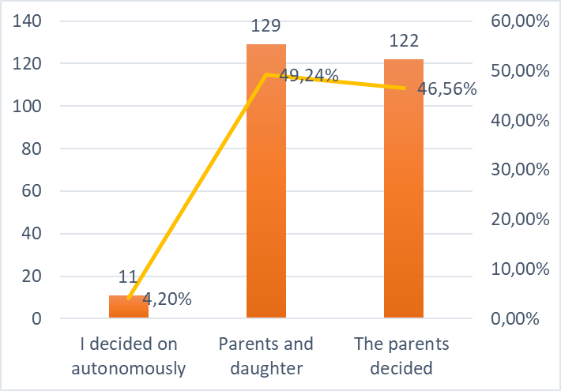 | 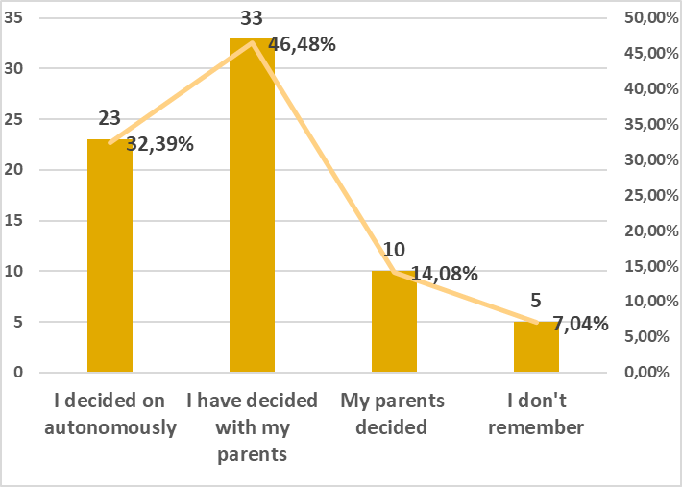
Figure 1: Vaccinated girls (N=262)  (Mean age : 20.14 [sd: 1.4035; 95% C.I(19.9587;20.3309)]) | Figure 2: Unvaccinated girls(N=85)  Mean age: 22.28 [sd: 4.3769; 95% C.I(21.1879;23.3746)]

HPV and Pap-smear knowledge were assessed by 14 items (yes/no/don’t know) and 4 items (yes/no/don’t know), respectively. Knowledge questions highlight a slightly better performance for unvaccinated girls while the information level considerably changes across faculties. Responses quality varies according to the question level, the more detailed is the information requested, the lower is the level of accuracy. Logistic and penalized regression models underlined the existence of several determinants associated with declining the HPV vaccination. These included citizenship, father’s age, mother’s education, HPV knowledge score (number of correct answers), sources of HPV information, duration of HPV vaccine protection and attitudes towards HPV vaccination (safety and side effects). The structural equation results showed that psychological dimensions are significantly interrelated, underlining the influence of social norms and attitudes in respondents’ behavioural intentions, i.e. future vaccination intentions (for unvaccinated girls) and future intentions to undergo a pap-test.

Conclusions
The studies presented in this thesis revealed that health behaviour, especially those related to vaccination choices, are shaped through a complex interplay of social-cognition determinants. Disposition towards other community members, social norms, beliefs and attitudes played an important role in predicting immunization decisions and should be taken into account when effective interventions are implemented. At the same time, the obtained results showed young girls still unable to make conscious and informed decision choices to protect their own health. Except for some unvaccinated respondents, girls appear unaware of the reason behind their vaccination and ignored most of the basic knowledge concerning HPV, HPV vaccination and pap-test screening

References
- Agresti A. An Introduction to Categorical Data Analysis. Vol 7. Second. John Wiley & Sons; 2008.
- Ajzen I. The theory of planned behavior. Organ Behav Hum Decis Process. 1991;50(2):179-211.
- Bonanni P, Levi M, Latham NB, et al. An overview on the implementation of HPV vaccination in Europe. Hum Vaccin. 2014;7 Suppl(February):128-135.
- Bruni L, Barrionuevo-Rosas L, Albero G, Serrano B, Mena M, Gómez D, Muñoz J, Bosch FX, de Sanjosé S. ICO/IARC Information Centre on HPV and Cancer (HPV Information Centre). Human Papillomavirus and Related Diseases in the World. Summary Report 27 July 2017. [10 August 2017]
- Chin WW. The partial least squares approach to structural equation modeling. In: Modern Methods for Business Research.1998:295-336.
- Hair JFJ, Hult GTM, Ringle C, Sarstedt M. A Primer on Partial Least Squares Structural Equation Modeling (PLS-SEM). Vol 46.; 2014.
- Harrell FE. Regression Modeling Strategies. With Applications to Linear Models, Logistic Regression, and Survival Analysis.; 2001.
- Hastie T, Tibsshirani R, Friedman J. The Elements of Statistical Learning. Springer; 2009.
- Herald zur, Hausen, Francoise B-S. The discoveries of human papilloma viruses that cause cervical cancer and of human immunodeficiency virus. Nobel Prize. 2008;(8):1-26.
- Lopalco, PL. Spotlight on the 9-valent HPV vaccine. Drug Des Devel Ther. 2017; 11: 35–44.
- Rosenstock, I. Social learning theory and the Health Belief Model. Health Education Quarterly.1998; 15(2):175–183.
- Tenenhaus M, Vinzi VE, Chatelin YM, Lauro C. PLS path modeling. Comput Stat Data Anal. 2005;48(1):159-205.
- Vinzi VE, Trinchera L, Amato S. Handbook of Partial Least Squares.; 2010.
- WHO. Human papillomavirus vaccines: WHO position paper, October 2014. World Heal Organ Wkly Epidemiol Rec. 2014;89(43):465-492.

1.Maria Veronica Dorgali, Dipartimento Economia e Management (Università di Pisa),; email: veronica.dorgali@gmail.com; 2. Luca Faustini, ISTAT- RMC Toscana; email: faustini@istat.it; 3.Michela Baccini, DISIA(Università di Firenze); email: michela.baccini@unifi.it 4.Alessandra Petrucci, DISIA(Università di Firenze); email: alessandra.petrucci@unifi.it,; 5.Angela Bechini, Dipartimenti di Sanità Pubblica(Università di Firenze); email: angela.bechini@unifi.it; 6.Paolo Bonanni, Dipartimenti di Sanità Pubblica (Università di Firenze); email: paolo.bonanni@unifi.it; 7.Barbara Pacini,Dipartimento di Scienze Politiche(Università di Pisa); email: barbara.pacini@unipi.it; 8. Piero Manfredi, Dipartimento Economia e Management (Università di Pisa), email: piero.manfredi@unipi.it.

