Fertility Drain or Fertility Gain? The Effect of Emigration on Fertility in Italian Municipalities during the Great Recession
L’effetto dell’emigrazione sulla fecondità nei comuni italiani durante la crisi economica.
Nicoletta Balbo and Massimo Anelli
Abstract The present paper aims at understanding how selection into emigration from Italy to other European countries may affect fertility in the municipal area of origin during the Great Recession. Exploiting the Administrative Registry of Italians Residing Abroad (AIRE) - that collects information about all Italian citizens moving their residence abroad – and birth records, we use an instrumental variable approach to analyze how emigration affects the Total Fertility Rate (TFR) at the municipal level. We find that municipalities with higher emigration rates experienced a greater decrease in TFR during the Great Recession, suggesting that people who has been emigrating from Italian municipalities to other European countries are those more at risk of having children.

Abstract Il presente lavoro studia come la selezione su chi emigra dall'Italia verso altri paesi europei possa influire sulla fecondità nell'area comunale di origine durante la Grande Recessione. Sfruttando il Registro Amministrativo degli Italiani residenti all'estero (AIRE) - che raccoglie informazioni su tutti i cittadini italiani che trasferiscono la loro residenza all'estero - e i dati sulle nascite, utilizziamo un approccio con variabile strumentale per analizzare come l'emigrazione influisce sul tasso di feconidtà a livello comunale. Troviamo che i comuni con tassi di emigrazione più elevati hanno subito un calo maggiore di TFR durante la Grande Recessione. Questo suggerisce che le persone che sono emigrate dai comuni italiani verso altri paesi europei sono quelle più a rischio di avere figli.

Key words: Fertility, Great Recession, Instrumental Variable, AIRE Data, Emigration

- Introduction
Existing demographic literature has provided evidence, even if not abundant in terms of quantity, of pro-cyclical effects on fertility, i.e., negative effect of economic downturns. Such evidence has consistently been found looking at both past recession periods (Currie and Schwandt, 2014) as well as the recent Great Recession (Goldstein et al., 2013).
However, existing literature on the topic has failed to consider a potential migration bias. With such a term, we refer to the potential effect that selection into migration may have on the compositional characteristics of the population in a certain area, thereby affecting local fertility rates.
Studying how selection into migration affects fertility during periods of recession is crucial, because it is especially in those times that people tend to move from regions in decline to those experiencing economic growth or less penalized by the crisis.
The present paper focuses on Italy, country in which the recent economic crisis has had a great impact, and that has consequently experienced a sharp increase in emigration (Anelli and Peri, 2017). Therefore, we are interested in understanding how selection into emigration from Italy to other European countries may affect fertility in the municipal area of origin during the Great Recession. Fertility in areas of larger emigration rates might be consistently higher or lower than in areas where the emigration rates are smaller, depending on who is selected into emigration.
That aspect has largely been overlooked in the literature on economic crisis and fertility. However, it is a crucial one, because the migration bias might produce either a over- or a under-estimation of the effect of the economic recession on fertility.
Therefore the present paper aims at addressing the following research questions: What is the causal effect of emigration on fertility rates in Italian municipalities during the Great Recession? Do municipalities with larger emigration rates systematically experience higher or lower fertility than those with smaller emigration rates?

- Theoretical framework
The present paper aims at uncovering whether selection into migration of people emigrating from Italy to other European countries during the recent economic crisis has any effect on fertility rates in the area of origin of emigrants.
Existing studies have shown that highly educated individuals are those more likely to move internationally because they expect the largest economic returns (Becker et al., 2004; Grogger and Hanson, 2011). Therefore two competing hypotheses might be put forward:
1. Being the higher educated individuals those who move, we could expect them to be more career-oriented and therefore less likely to be at risk of having children. As a result, we might observe higher fertility rates in municipalities with larger emigration rates, because individuals who stay are those more at risk of having children.
2. Conversely, some studies (Hazan and Zoabi, 2014) have found that, in recent years, higher educated individuals are more likely to have children because they have the resources to buy house-related and child-related services from the market, which allow them to work and have higher fertility. If emigrants are selected among those individuals who have a higher risk of having children, municipalities with larger emigration rates would experience lower fertility. This second competing hypothesis is further supported by the argument that willingness to take risks positively and significantly affects the probability of both emigrating (Heitmueller, 2005) and having children (McDonald, 2006), suggesting once again that emigrants are more likely to have children than the stayers.

- Analytical strategy
Establishing a causal link from emigration to fertility is challenging, because the factors triggering migration (e.g. unemployment) might also cause simultaneous changes in fertility patterns making it difficult to separately identifying the effect of emigration from the effect of economic conditions. To overcome this identification problem, the present paper plans to exploit reach administrative data and an instrumental variable approach. The main data sources are the Administrative Registry of Italians Residing Abroad (AIRE) - that collects information about all Italian citizens moving their residence abroad – and birth records.
The instrumental variable approach leverages the difference between “push” and “pull” factors of emigration. While push factors are specific to the municipality of emigration and likely correlated with local economic and political conditions, pull factors depend on receiving countries’ conditions. These latter factors are likely not correlated with those at the municipality of origin. Following Anelli and Peri (2017), we exploit the richness of AIRE data to isolate a component of emigration that depends on pull factors only. We consider the growth of gross domestic product in the countries receiving Italian emigrants, interacted with the presence of pre-existing networks of Italian emigrants in each receiving country. As the economic growth was much slower in the Mediterranean economies (Greece, Spain, Italy, France) than in Northern Europe, the pull to emigrate was much stronger for municipalities that had large pre-existing networks with Northern EU countries such as Germany, Switzerland and the UK than with Southern ones. The presence of links to specific countries in the form of networks of pre-2000 emigrants - who reduce the cost of migrating to those countries - allows us to construct the municipality-specific emigration “pull factor” that we use as an instrument to measure the effect of emigration on fertility in Italian municipalities.

- Preliminary findings
Leveraging birth records and population data on women in reproductive age, we have calculated municipality-specific total fertility rates (TFRs). Figure 1 shows a heat map of all Italian municipalities by intensity of change in TFR during the recession (between 2007 and 2014). Light-coloured municipalities had decreases in TFR, with 20% of all municipalities having a decrease of more than 0.33 with respect to a baseline average TFR of 1.319 in 2007. Darker municipalities instead had an increase in TFR. While the average change in this period was a decrease in TFR of 0.054 points, the map shows that there is substantial variation across municipalities even within same areas. With our econometric model, we are going to exploit this cross municipalities variation within relative small areas (110 provinces).
As showed in Anelli and Peri (2017) the great outflow of Italians migrating abroad started in 2010 and dramatically increased in the following years. Figure 2 shows the intensity of this phenomenon by comparing it with the severity of the unemployment rate increase during the recession. Figure 3 splits the emigration flows by human capital intensity of the municipality of origin of the emigrants and shows that the great outflow was represented by Italians leaving municipalities with higher shares of college educated.
To estimate the causal effect of emigration on fertility we estimate the following model:

where the dependent variable TFR_m,2014 is the total fertility rate at the end of the recession in municipality m, ΔEmig_m is the cumulated outflow of emigrants in municipality m during the recession relative to initial population, X_m are pre-recession (2004) controls such as unemployment rate and GDP in the local labor market in which the municipality is located and λ_province are province fixed effects. We control for the pre-recession fertility level (TFR_m,2007) in each municipality to take into account baseline differences in fertility across municipalities.
Table 1, column 1 shows results from estimating this model with a simple OLS approach. The effect of emigration is negative and significant, however the OLS model is likely to suffer of the endogeneity issues described above (for instance areas that suffer higher unemployment have both emigration and a decrease in fertility). Column 2 then shows results after instrumenting the emigration rate with our pull-factor instrumental variable (IV) as described in the previous section. The estimated effect is statistically significant and large. An increase in emigration of 1% of the population leads to a decrease of 0.324 on a baseline average TFR in 2007 of 1.319 (equivalent to a 25% decrease). In columns 3 and 4 we continue leveraging out IV approach and stratify the analysis by dimension of the municipalities with cities defined as municipalities with more than 10000 inhabitants. The negative impact of emigration on fertility seems concentrated in small towns below this dimension threshold. Finally, in columns 5 and 6 we separately focus on municipalities with a share of college educated above the national median and those with a share below the median. Interestingly, results show that the negative effect is equally strong in both highly educated and low educated municipalities.

Figures and Tables
Figure 1 – Pre- vs post-great recession change in total fertility rate at municipal level between
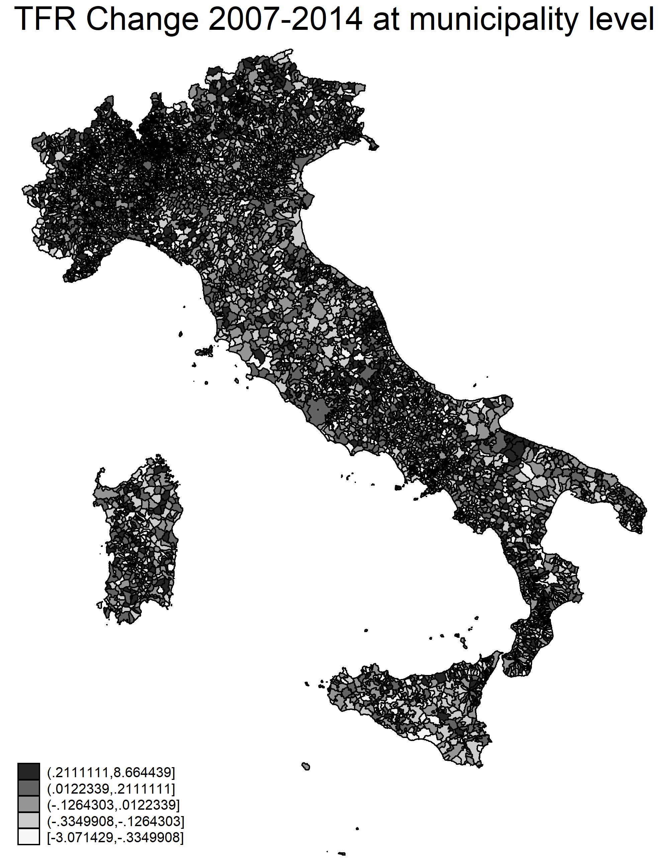

Figure 2 – Number of Italians migrating abroad per year vs unemployment rate
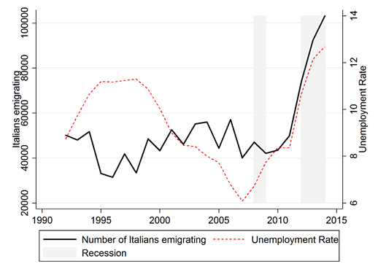
Note: Reproduced from Anelli and Peri (2017)

Figure 3 – Number of Italians emigrating per year by share of college educated individuals in the origin municipality

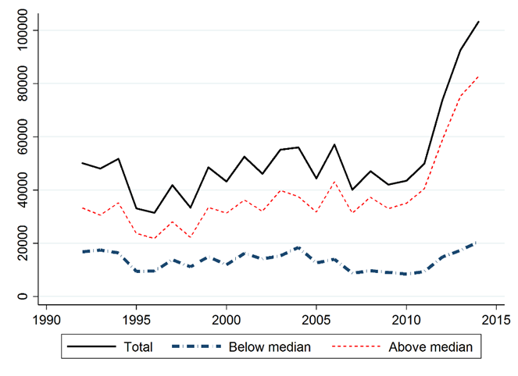
Note: Reproduced from Anelli and Peri (2017)

Table 1 - Effect of 2010-2014 Emigration on 2014 TFR level, controlling for 2007 TFR at municipality level with province fixed effects.
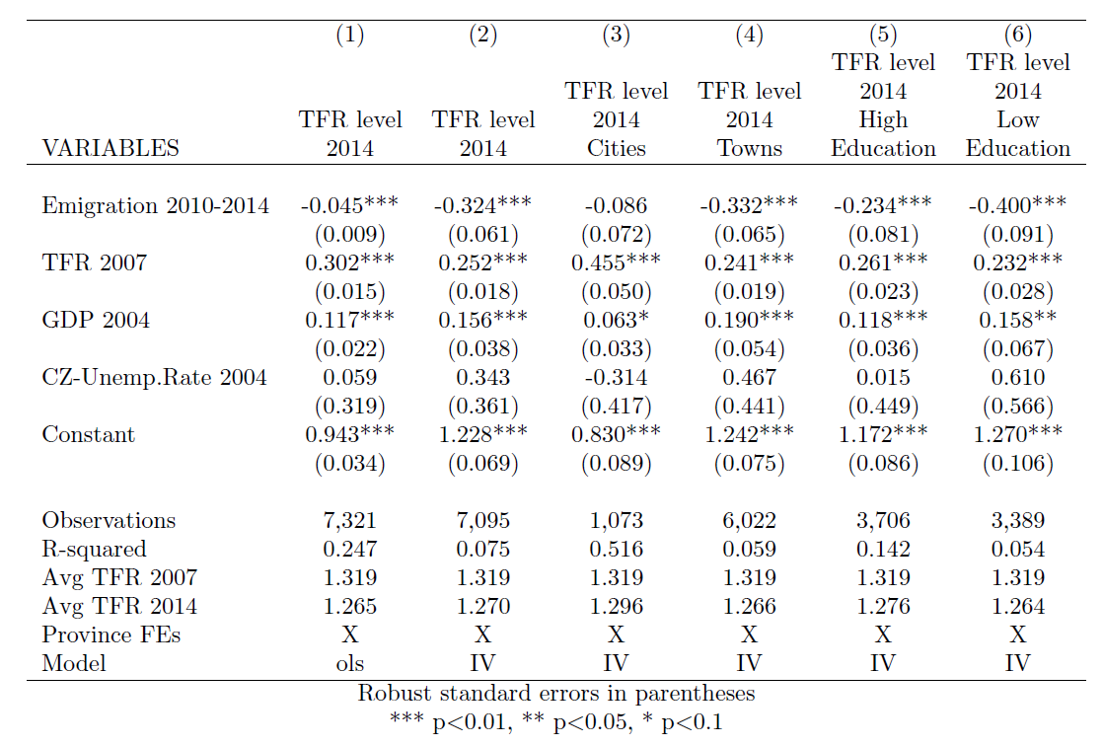

Dondena Centre, Bocconi University, Milan, Italy
Dondena Centre, Bocconi University, Milan, Italy

