The emergency department utilisation among the immigrant population resident in Rome from 2005 to 2015

*L’accesso al pronto soccorso da parte degli immigrati residenti a Roma tra il 2005 e il 2015*

Eleonora Trappolini, Laura Cacciani, Claudia Marino, Cristina Giudici, Nera Agabiti, Marina Davoli [1]

**Abstract**

Health inequalities affecting migrant population have been largely analysed in the literature, but only scarce studies have been published on migrant’s utilisation of Emergency Departments (EDs). The aim of this study is to analyse trends of EDs utilisation for the population resident in Rome during the period 2005-2015, overall and for specific causes. By comparing immigrants’ access with that of the host population, the study evaluates differences in the healthcare utilisation rate between these populations. The analysis is based on a dynamic cohort aged 25 to 64 years old in each year and defined using data from the Municipal Register of Rome. Results on the overall utilisation rate show a lower use of the EDs by the immigrant population with respect to the host population, although this gap has started to decrease in the years after the 2008. Even if the overall utilisation rates show similar trends between Italians and immigrants, different patterns have been detected for specific causes.

**Abstract**

Le disuguaglianze di salute legate alla condizione migratoria sono state oggetto di numerose analisi in letteratura. Tuttavia, nel panorama europeo, gli studi sull’accesso degli immigrati al servizio di pronto soccorso risultano ad oggi scarsi e spesso contraddittori. Questo contributo è volto ad analizzare l’accesso al pronto soccorso da parte della popolazione italiana e straniera residente a Roma tra il 2005 e il 2015.

L'analisi si basa su una coorte dinamica di età compresa, ogni anno, tra 25 e 64 anni, definita utilizzando i dati dell’Anagrafe Comunale di Roma. I risultati mostrano un minore accesso all’emergenza per gli stranieri rispetto agli Italiani, anche se il gap mostra una riduzione dopo il 2008. In generale le due popolazioni mostrano comportamenti simili, mentre emergono differenze dal confronto per specifiche cause di accesso.

**Key words:** Emergency Department utilisation, Immigrant population, Dynamic cohort, Time trends, Rome

1. Introduction

During the last decades, the number of immigrants in Italy has continued to increase, reaching 5,047,028 (8.3%) in 2016 (Istat, 2016). On this basis, migration is no longer a transient phenomenon as in the 1970s, but it should be considered as a structural component of our society.

The WHO Commission on Social Determinants of Health recently highlighted the rise of new health inequalities between and within countries due to differences in social class, gender and ethnicity, as far as inequalities in the access to healthcare services among migrants and natives (Malmusi et al., 2010). Access to healthcare should be seen as no less important than housing and education for the wellbeing. Actually, it can be considered a proxy of the integration process (Ingleby et al., 2008).

At present, only scarce and often contradictory data have been published on migrant’s utilisation of healthcare services in Europe (Norredam et al., 2004; Rué et al., 2008), and even less information is available on migrant’s utilisation of Emergency Departments (EDs). Although the literature shows different scenarios (Zinelli et al., 2014; De Luca et al., 2013), there is a general consensus about the immigrants’ higher use of emergency room services than that of non-migrants (Cots et al., 2007; Ruud et al., 2015). In Italy, a retrospective analysis based on 2005 Italian Health Conditions Survey, carried out by the Italian National Statistical Office, registered a higher Emergency Department utilisation rate by immigrants, notably from Morocco, other African countries and Albania (De Luca et al., 2013). These differences may be partly explained first of all by obstacles in the access to primary care, which are related to the migrant status, but also by different factors mainly related to the perceptions of illness or to the so called *health literacy.*

In Italy, some recent studies investigated the health of immigrants (Pacelli et al., 2016; Cacciani et al., 2011); however, as far as we know, no evidence is available about the health service utilisation of Italians and immigrants during the recent Great Recession.

While immigrant flows have increased rapidly in the last decade, we hypothesize that under the conditions to which immigrants are exposed because of their status, they might not use the medical system in the same way as the Italian population.

The objective of this study is twofold. Firstly, it investigates the possible differences in the EDs utilisation between immigrant and Italian residents in Rome. Secondly, it compares the EDs utilisation between the periods before and after the 2008.

1. Materials and methods

An observational study based on a dynamic cohort, defined using data from the Municipal Register of Rome, has been performed to evaluate the healthcare utilisation rate of Italians and that of the immigrant population, during the last decade.

The study population includes all residents in Rome, aged 25 to 64 years old between 1st January 2005 and 31st December 2015 in each year (2,184,467 individuals). Emergency Department data, gathered from the Regional Health Information System on Emergency Care in Lazio, were linked to the subjects using an individual anonymised code. An average of 390,000 visits by year has been observed. The available data include information about gender, birthdate, birthplace, citizenship, as well as medical information. Diagnoses and procedures are coded according to the ICD-9-CM.

The outcome variable is the overall number of EDs contacts. The immigrant status is the exposure variable (immigrants vs Italians). The most appropriate information to identify immigrants is still being debated (Malmusi et al., 2010). This study defines as immigrants those individuals without the Italian citizenship, distinguishing them between immigrants coming from High Migratory Pressure Countries (HMPCs)[2] and coming from Highly Developed Countries (HDCs). Since we are dealing with people resident in Rome, other migrant categories have been excluded. In order to explore differences in the emergency access, we performed descriptive analyses which aimed to investigate the pattern of EDs use by immigrants living in Rome (overall and for specific causes[3]), comparing it with that of the resident Italian population. Crude utilisation rates (URs), using person years, and direct age-standardized URs, by gender and for both immigrants and Italians, have been computed using the Italian population residing in Lazio at 1st January 2014 as standard population. The following age groups have been considered: 25-29, 30-34, 35-39, 40-44, 45-49, 50-54, 55-59, 60-64.

Negative binomial regression was used to estimate rate ratios (RRs) with 95% confidence intervals in order to evaluate differences in the EDs utilisation between immigrants and Italians, adjusting for gender, age, socio-economic position (SEP)[4], and stratifying by time period.

1. Results

The total number of ED contacts during the period 2005-2015 was 4,297,981.

Immigrants as a whole had a lower UR than Italians, and this trend was similar in all age groups, except for the youngest women aged 25-29 (39.9 x 100 py compared to 37.5 x100 py for Italians). Women had higher overall URs than men in all groups of geographical origin (Fig. 1.a).

Of the two immigrant groups examined, those coming from HDCs registered the lowest rates. As figures show, even if the highest rate belongs to Italians, a similar trend between Italians and immigrants coming from HMPCs has been detected. Although the overall UR, both for men and women, varied slightly over the study period (Fig. 1.a), the access for specific causes showed different patterns. For the specific causes analysed, men always registered higher URs compared to women, except for both the causes related to mental disorders, where we observed a higher but constant UR among women coming from HMPCs, and injuries where women coming from HDCs registered a higher UR (Fig. 1.b). Concerning contacts for injuries we observed decreasing patterns especially among Italian men (Fig. 1.c). While the UR for mental disorders was fairly constant and that for injuries was declining, the contacts for cardiovascular-related causes registered an increasing pattern among all groups, especially for immigrants. In addition, immigrant men registered a higher UR with respect to Italian women (Fig. 1.d).

**Figure 1. Overall and cause-specific (mental disorders, injuries, and CVDs) age-standardized UR of residents in Rome, by gender and area of origin. Lazio, years 2005-2015**

**Figure 1a.** Overall **Figure 1b.** Mental disorder

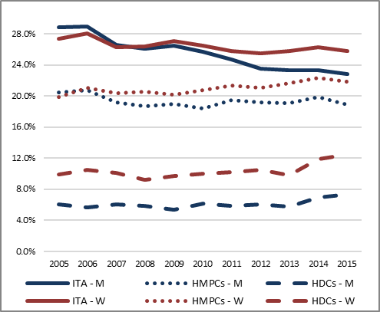  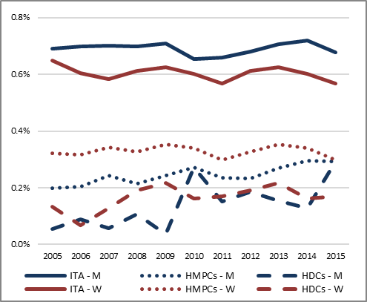

**Figure 1c.** Injuries  **Figure 1d.** Cardiovascular diseases

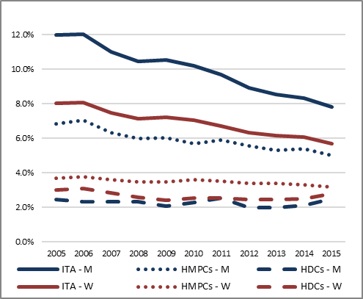 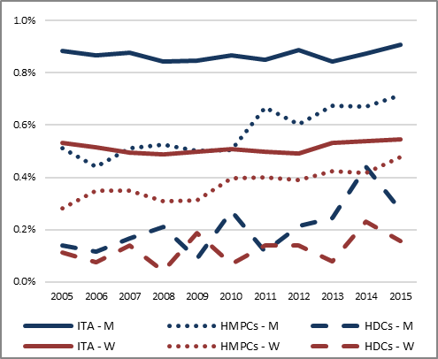

Table 1 shows the results from the Negative Binomial regression analysis. Italians were used as the reference group when comparing area of origin, men were used as a reference group when comparing gender and those with a high socio-economic position were used as a reference group when comparing the SEP. Age was considered as a continuous variable. An overall highly significant association was found between EDs utilisation rates and area of origin (*p*<0.0001). When controlling for age, gender and socio-economic position, immigrants registered a lower UR compared with Italian residents. A highly significant association was also found between the socio-economic position and utilisation. Table 1 shows how URs increase with decreasing SEP. Moreover, women registered higher URs with respect to men and the URs decrease with age. Comparing the period before and after the 2008, results show that patient behaviours are fairly constant in the two periods, however during the years analysed a reduction in the gap between the Italian population and the immigrant population (HMPCs) has been observed.

Table 1. Negative Binomial regression: rate ratios (with 95% confidence intervals) of ED utilisation for immigrant compared to Italian resident population in Rome, adjusted for age, gender, and socio-economic position, and stratified by time period. Lazio, years 2005-2015.



Our results show lower utilisation of the ED (overall) among immigrants during the period 2005-2015, in Rome. This result is consistent with previous reports of healthcare utilisation by the immigrant population and was probably due to the *healthy immigrant effect* (Carrasco-Garrito et al., 2007; Norredam et al., 2007) where recently arrived immigrants have better health status than natives because of a previous *selection process* in each country of origin. Consideration should be also given to the fact that we are dealing with immigrants who are resident in Rome, it means they have a residence permit and most of them have a work, thus they are also positively selected compared to other migrant categories. Moreover, other studies have shown no relationship between the perceptions of need, willingness to seek health services and ethnicity (Adamson et al., 2003), and more evidence is provided towards the hypothesis that barriers occur at the access of the services (Okie et al., 2007).

However, it would be interesting to analyse the access for specific causes, in which we detected different patterns, and to explore the hospitalization. Furthermore, even if the relationship between the SEP and the ED utilisation was expected, in this context the SEP was used for adjusting the exposure, but because the mechanism behind the interaction of this two variables is complex, further insights are necessary. Concerning comparative analyses, we will also should consider other factors which may have contributed to the modification in the EDs utilisation, as the Great Recession and the austerity policies implemented by the region.

References

1. Adamson J, Ben Shlomo Y, Chaturvedi N, Donovan J: Ethnicity, socio-economic position and gender-do they affect reported health-care seeking behaviour? pp. 895-904, Soc Sci Med (2003)
2. Cacciani L., Asole S., Polo A., Franco F., Lucchini R., De Curtis M., et al., Perinatal outcomes among immigrant mothers over two periods in a region of central Italy, p. 294. BMC Public Health (2011)
3. Carrasco-Garrido P, De Miguel AG, Barrera VH, Jimenez-Garcia R., Health profiles, lifestyles and use of health resources by the immigrant population resident in Spain, pp. 503-507, Eur J Public Health (2007)
4. Cots F., Castells X., Ollé C., Manzanera R., Varela J., Vall O., Perfil de la casuística hospitalaria de la población inmigrante de Barcelona, pp. 376-384. Gaceta Sanitaria (2007)
5. De Luca G., Ponzo M., Andres A.R., Health care utilization by immigrants in Italy, pp. 1–31. International Journal Health Care Finance Econ (2013)
6. Ingleby D., New perspectives on migration, ethnicity and schizophrenia, Willy Brandt Series of Working Papers in International Migration and Ethnic Relations 1/08, Malmö University, Malmö (2008)
7. Istat (2016), Bilancio demografico nazionale:

http://www.istat.it/it/files/2017/06/bilanciodemografico201613giugno2017.pdf?title=Bilancio+demografico+nazionale++13%2Fgiu%2F2017+-+Testo+integrale.pdf

1. Malmusi D., Borrell C., Benach J., Migration-related health inequalities: showing the complex interactions between gender, social class and place of origin, pp.1610-1619. Social Science & Medicine (2010)
2. Norredam M., Krasnik A., Sorensen T.M., Keiding N. et al., Emergency room utilization in Copenhagen: a comparison of immigrant groups and Danish-born residents, pp. 53-59. Scandinavian Journal Public Health (2004)
3. Norredam M, Mygind A, Nielsen AS, Bagger J, Krasnik A: Motivation and relevance of emergency room visits among immigrants and patients of Danish origin, pp. 497-502, Eur J Public Health (2007)
4. Okie S: Immigrants and health care--at the intersection of two broken systems, pp.525-529, N Engl J Med (2007)
5. Pacelli B., Zengarini N., Broccoli S., Caranci N., Spadea T., Di Girolamo C., et al., Differences in mortality by immigrant status in Italy. Results of the Italian Network of Longitudinal Metropolitan Studies, pp. 691–701. Eur J Epidemiol (2016)
6. Rué M., Cabré X., Soler-Gonzalez J., Bosch A., Almirall M., Catalina Serna M. Emergency hospital service utilization in Lleida, pp. 1-8. BMC Health Service Research (2008)
7. Ruud S.E., Aga R., Natvig B., Hjortdahl P., Use of emergency care services by immigrants-a survey of walk-in patients who attended the Oslo Accident and Emergency Outpatient Clinic, pp. 15-25. BMC Emerg Med (2011)
8. Zinelli M., Musetti V., Comelli I., et al., Emergency department utilization rates and modalities among immigrant population. A 5- year survey in a large Italian urban emergency department, pp.22–25. Emerg Care Journal (2014)

1. Eleonora Trappolini, Sapienza University of Rome; email: eleonora.trappolini@uniroma1.it

   Cristina Giudici, Sapienza University of Rome; email: cristina.giudici@uniroma1.it

   Dipartimento di Epidemiologia del Servizio Sanitario Regionale del Lazio – ASL Roma 1:

   Laura Cacciani: l.cacciani@deplazio.it

   Claudia Marino: c.marino@deplazio.it

   Nerina Agabiti: n.agabiti@deplazio.it

   Marina Davoli: m.davoli@deplazio.it
2. Central-Eastern Europe (including Poland and Romania), North Africa, Sub-Saharan Africa, Asia (except for Israel and Japan), and Central and South America
3. Mental disorders (ICD-9-CM 291-312), injuries (ICD-9-CM 800-959), and cardiovascular diseases (ICD-9-CM 401-445).
4. The SEP indicator (from 1 higher to 4 lower) is based on the characteristics of the census block of residence (that is the smallest territorial unit for which population data were available).