Detection of damage in civil engineering structure by PCA on environmental vibration data
Valutazione del danno in opere infrastrutturali mediante PCA su dati di vibrazione ambientale
G. Agrò, V. Carlisi, R. Mantione
Abstract The dynamic behavior of civil engineering structures is usually studied by means of ambient vibration observations and their performance is analyzed by Peak Picking and/or Operational Modal Analysis methods. This paper reports the first results of a statistical multivariate approach, specifically Principal Component Analysis, to detect a suspected structural damage on a Sicilian highway bridge.
Furthermore, the damage simulated in a simple structural model made it possible to understand the characteristics of the method consisting in comparing the observed data on an undamaged structure with those coming from a damaged one.
Riassunto Il comportamento dinamico nelle costruzioni civili viene usualmente studiato attraverso prove di caratterizzazione dinamica utilizzando il metodo del Peak Picking e/o quello dell’Analisi Modale Operazionale sul dominio delle frequenze. Il presente lavoro riporta i primi risultati di un approccio statistico multivariato, in particolare l’Analisi in Componenti Principali, al fine di determinare un possibile danneggiamento strutturale di un ponte autostradale siciliano.
Infine la simulazione del danno in un modello strutturale semplice ha permesso l’individuazione delle variazioni di parametri significativi del metodo utilizzato confrontando i risultati del modello danneggiato con l’omologo integro.

Key words: Principal Component Analysis, Damage Detection, Subspace Angles, Operational Modal Analysis, Fast Fourier Transform, Peak Picking technique.

- Introduction
One of the most used approaches for damage detection in engineering structures is environmental vibration test that allows the gathering of natural frequencies and obtaining the so-called mode shapes and structural dampings. The test is performed using a predetermined number of uniaxial piezometric accelerometers connected to a control unit for the acquisition of environmental acceleration times. By means of Fast Fourier Transform (FFT), the time series are transferred to the frequency domain and the Peak Picking and the Frequency Domain Decomposition (FDD) techniques were used to extract the dynamic parameters from the spectral densities matrices.
The Peak Picking (PP) method leads to reliable results provided that the basic assumptions of low damping and well-separeted modes are satisfied. In fact this method allows to identify the operational deflection shape that, in the case of closely modes, represent the overlap of numerous modes. The Frequency Domain Decomposition (FDD) technique, which represents a significant improvement of the PP, through the Singular Value Decomposition (SVD) of the spectral densities matrices, is able to detect closely spaced modes: the singular value will have a maximum in the resonant frequencies [3,4].
A recent approach in the context of damage identification on engineering structures is the analysis of the principal components (PCA) applied to investigate the existence of any change between a suspected damaged structure and an undamaged similar one adopted as a reference model. The results of the n experimental tests, obtained by means of p sensors, constitute the X matrix, of dimension nxp, which is the starting point for the PCA. The aim of PCA is to reduce the space of p correlated variables in such a way do not lose the bulk of information contained in the data. In synthesis from the data collected in X, the correlation matrix R is calculated such as eigenvectors and eigenvalues of R which are used to identify the subspaces among which choosing the reduced dimension k<p corresponding to a fixed amount of the system variance [1]. This procedure is adopted for the matrix X deriving from the healthy structure and for the matrix Y from the damaged structure. The selected subspaces, one for each systems, are compared by means of the maximum angle θ between the subspaces [6].
Section 2 shows the simulation study, while section 3 shows the results of the analysis on a Sicilian motorway bridge; finally, in section 4, some conclusions are drawn.
- Numerical application
The system, consisting of two equal masses connected in series through linear springs and adopted for the simulation study (Figure 1), is named a two-degree-of-freedom system (2DOF) and is subject to a free harmonic movement with a natural frequency ω.
The system responses are the vectors u₁ and u₂ that representing respectively the displacement of mass m₁ and mass m₂..
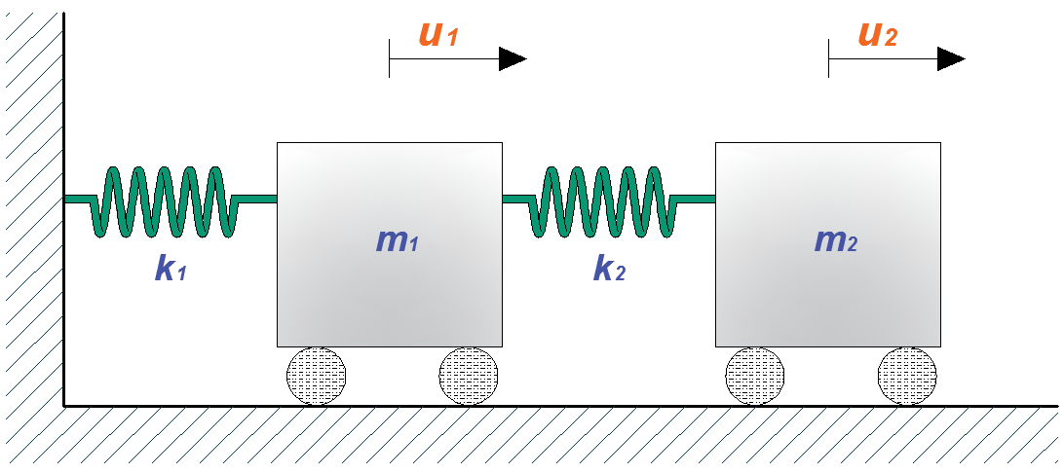
Figure 1: Two degree of freedom mass-spring model undamped and unforced vibration system
The homogeneous linear differential equations of motion, for the 2DOF system, can be written as
M ü(t) + K u(t) = 0
or in extended matrix form
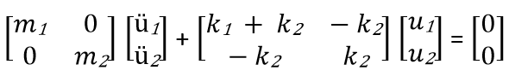
where M is a diagonal mass matrix, K is a stiffness matrix, while u and ü are vectors of time varying displacements and accelerations respectively. The trial solution u=Ucos(ωt-φ) with ω natural frequency, φ phase and U time independent amplitude vector, lead to solve the classical eigenvalue problem
(K - λ M)U = 0
where λ_{i}, i=1,2 are the eigenvalues. The eigenvalues so obtained depend only from physical parameters of the system. The replacement of λ_{i}=ω_{i}² in the classical eigenvalue problem allows to found the eigenvectors U_{i} corresponding to the natural frequencies, the so-called mode shapes [4]. The response of the system is calculated with a sampling frequency of 0.03 sec and the damage is simulated by varying the stiffness of a single spring [5], (k₁=k₂=213'330 N/cm, k₂=1, 5, 10, 15, 20, 30 and 40% of k₁), leaving the masses unchanged, m₁=m₂=9700 N, and giving an initial displacement. Finally, the simulated response data were perturbed by adding, to each of the time series, a white Gaussian noise with S_{d} = 15% of the Root Mean Square value of the respective series [2,7]. Natural frequencies were obtained by using the FFT technique that allows to transform the responses from the time domain to the frequency one where we can read the abscissa value of the peaks showed in the graphic of the power spectral density (Figure 2).
Observing Figure 2, where the spectra of the different system conditions are presented (level of damage from 0% to 40%), it is very difficult to detect the presence of damage since the abscissa values of the first peak (frequency) are coincident while for the second one (frequency) the abscissa range variation is very small.

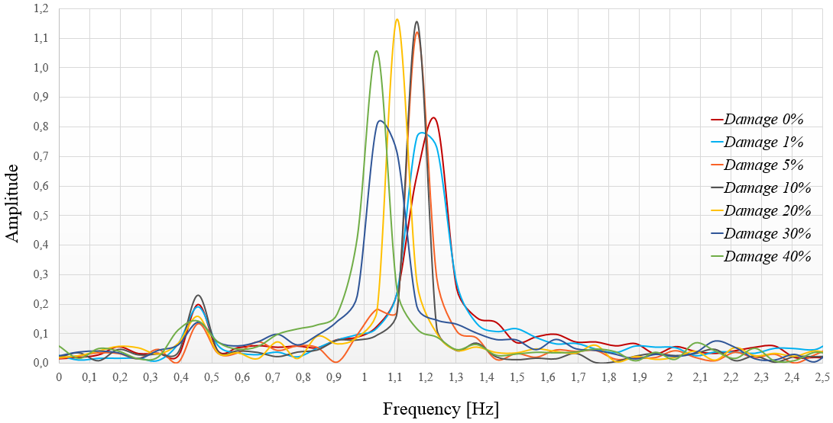
Figure 2: Comparison of frequency
The results of the Principal Component Analysis, applied to the described model, are shown in Figure 3 where the scatterplot of (u₁(t),u₂(t)), of the undamaged system is presented and the orthogonal axes (PC1, PC2), a couple for each level of damage, are superimposed.
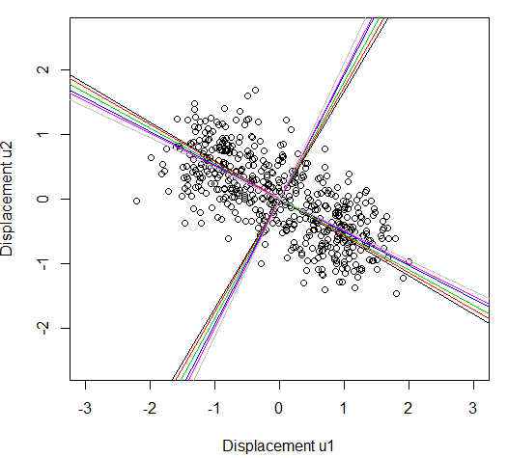
Figure 3: Scatterplot of u₁,u₂ and rotation of the PCA axes for damaged systems
The black axes are related to the undamaged system (dam=0%) and the others are for the systems damaged in increasing way. It can be noted that there is a rotation (in counter-clockwise) of the PC_{i} axes. The angles θ_{i} between the black and colored axes could be considered as a measure of the extent of the damage as we will see in the next section.
- Damage detection: the case of a sicilian highway bridge
The case study concerns a Sicilian highway bridge [8], built in the 70s and 1533 m long; it includes 35 reinforced concrete spans. The bridge consists of isostatic spans, each of which has a deck consisting of four pre-stressing R.C. beams with double T section; each span is 45 m long and 9.8 m wide. Ambient vibration tests were conducted on two adjacent spans 8, considered undamaged, and 9, suspected damaged, using ten uniaxial piezoelectric accelerometers, Figure 4 shows the layout of the sensors. The ambient acceleration time histories were recorded for 2400 sec at interval of 0.01 sec. The present study was conducted using only six vertical sensors, in Figure 4 the red ones, and data were collected in matrices of dimension (240000x6).
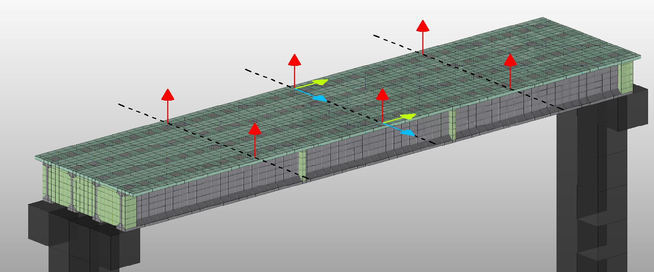
Figure 4: Location of the sensors on the bridge deck
Operational Modal Analysis, according to FDD technique, was used to identify natural frequencies and mode shapes. By comparing the frequency of the spectra of the two spans (Figure 5), the difference in abscissa values of the peaks is very low (less than 10%) and consequently, by means of the PP technique, it is difficult to detect a damage.
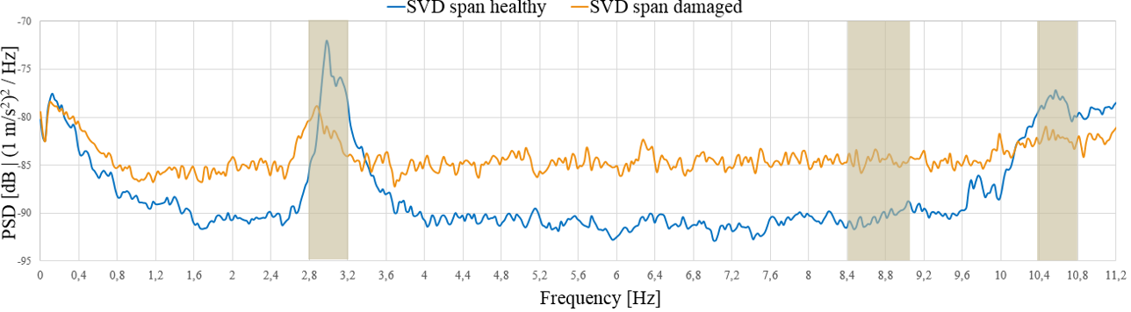
Figure 5: Singular Values of Spectral Densities of Test Setup

The application of the PCA to study the behaviour of healthy span (n.8 matrix X) and damaged span (n.9 matrix Y) led to the identification of optimal four-dimensional subspaces since the percentages of the total variance explained were 75% for healthy span and 80% for damaged span.
In order to measure the difference among the spans, the principal angle between the four-dimensional subspaces was calculated [6]:

subject to
where D_{(6x4)} and H_{(6x4)} are the matrices of eigenvectors for the damaged and healthy span respectively.
In our case the difference between the two spans exists and it is showed by the angle θ=arcos(-0.7429298)=42°; on this result it is evident that the span 9 has a damage.

Table 3: Cos(θi) calculated by formula (1): maximum value red coloured
H vs D | PC1 | PC2 | PC3 | PC4
PC1 | -0.7429298 | 0.2386534 | 0.3945228 | -0.3908226
PC2 | -0.5139214 | 0.2406920 | -0.2453405 | 0.3750808
PC3 | -0.3328730 | -0.1497690 | -0.6219700 | 0.3301877
PC4 | -0.1773170 | -0.6197478 | -0.3634516 | -0.6058055
- Conclusion
The paper presents an investigation of the damage detection capability of the Principal Component Analysis applied to the response structural vibration tests in time domain. The numerical simulation here reported is a starting point of a complete simulation study on different structural models.
On the case study, the analysis of the vibration tests by Peck Peaking technique did not produce easily interpretable evidence while the analysis of the subspaces resulting from the reduction by means of PCA gave evidence of the damage present in the structure.

References
- Anderson T. W.: An introduction to multivariate statistical analysis, Wiley (2003)
- Brandt A.: Noise and Vibration Analysis – Signal Analysis and Experimental Procedures. Wiley (2011)
- Brincker R.,Ventura C.: Introduction to Operational Modal Analysis. Wiley. (2015).
- Ewins D.J.: Modal Testing – Theory, practice and application. Research Studies Press Ltd., England (2000)
- Friswell M.I: Damage Identification using Inverse Methods In Morassi A., Vestroni F. Editors: Dynamic Methods for Damage Detection in Structures, pp. 13-66, Springer Wien New York (2008)
- Golub G., Van loan C.: Matrix computations. The Johns Hopkins University Press, Baltimore (1996)
- Poncelet F., Kerschen G., Golinval JC., Experimental modal analysis using blind source separation techniques - International Conference on Noise and Vibration Engineering, Leuven (2006)
- Technical Report n° 51216-2, DISMAT (2017)

Gianna Agrò, DSEAS, University of Palermo; email: gianna.agro@unipa.it Valentina Carlisi, Laboratorio DISMAT; email: valecarlisi@libero.it Roberta Mantione, Laboratorio DISMAT, email: robertamantione.rm@gmail.com

