A methodological approach to the environmental Umbria data
Un approccio metodologico per i dati ambientali umbri
Marta Bosi, Monica Franzese, Cristiano Trani, Sandra Verduci
Abstract
The environment has an important role in people’s health; it’s very difficult to determine the effect of several different pollutants in air, water and soil. The aim of this work, based on Arpa Umbria’s databases (e.g., [1,3,4,5]), is to provide an analytical method to determine the presence of environmental pollutants in a geographical area by using a cartographic representation on a 5Kmx5Km grid. To this end, a composite indicator has been constructed to measure the level of different kinds of environmental. The information provided by the sampling of laboratory parameters has been summarized, on the basis of simple indicators calculated for each parameter and appropriately weighted by applying the Probabilistic Principal Components Analysis (PPCA).
Abstract L’ambiente ha un ruolo decisivo sulla salute umana; è particolarmente difficile stabilire l’effetto risultante dei vari inquinanti presenti in aria, acqua e suolo. Il presente lavoro, realizzato a partire dai dati di Arpa Umbria (e.g., [1,3,4,5]), intende fornire una rappresentazione cartografica significativa della presenza degli inquinanti sul territorio, avvalendosi di una griglia di 5Kmx5Km. A tale scopo è stato costruito un indicatore composito che misura il grado di inquinamento ambientale proveniente da diverse origini; sono state sintetizzate le informazioni provenienti dai campionamenti dei parametri di laboratorio, a partire da indicatori semplici, calcolati per ogni parametro e pesati in maniera opportuna, applicando una strategia basata sull’analisi delle componenti principali di tipo probabilistico (PPCA).

Key words: Environmental indexes and indicators, reticular cartography, normalization, correlation and Pearson coefficient, Principal Component Analysis, Expectation-Maximization algorithm.

- Introduction
The present work is based on environmental data collected by the Regional Agency for Environmental Protection of Umbria; it proposes a statistical approach defining a composite indicator to study the environmental status of the Umbria region in the presence of different pollutants impacting on different environmental matrices and whose comparability is therefore complex.
- Data presentation
  - Description
Information related to laboratory samples is used, including the sampling point and the values ​​of the analyzed parameters. Each sampling point is associated with a well-defined environmental entity (“environmental unit”) that characterizes the sampling point. Some examples of environmental units are well water, rubbish dumps, agricultural areas, productive activities.
Moreover, each sample is associated with a "chain", that is a series of information that has the objective of detailing the environmental matrix to which the sample refers (see Figure 2). This information is composed of:
- Type;
- Class;
- Subclass.
Information from the air monitoring units was also used to acquire the data of the main atmospheric pollutants at an hourly rate.
The data are acquired through ETL (Extract, Transform, Load) and then integrated into a special OLAP data-mart for the necessary statistical processing. A dimensional Fact Data Model was used whose dimensions are: sample, geographic point, analyzed parameter and time (see Figure 2).
To build an integrated mapping system based on the overlap of different environmental layers, the data is imported and therefore each sampling point is associated with a geographical intersection with a grid unit of 5Kmx5Km (see Figure 5).
  - Statistical data analysis and normalization strategy
Each parameter, associated with its environmental chain/environmental unit, has different values according to its particular statistical distribution. For this reason the normalization (e.g., [5]) is a primary and required step. The normalized values are calculated for each parameter according to the entire classification chain as follows:

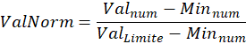

where and are respectively the detected value and the minimum detected value.
is the upper normative limit if present; otherwise, the 75th percentile of the distribution is considered.
This normalized value (called ValNorm) is compared with the z-score normalization. The comparison shows that the ValNorm contains the outlier values and therefore it highlights the smaller but significant variability of some parameters, such as tetrachlorethylene (e.g., [2]).
  - Environmental parameters correlation and the missing data problem
To analyze the correlation between the parameters, the Pearson correlation coefficient is estimated by applying a passive strategy useful to manage the missing data (listwise delation); it allows the exclusion of an entire record from the analysis if any single value is missing. For each year, correlation matrices are computed for the sixteen environmental units.
The high level of analysis disaggregation shows many anomalies for a significant number of environmental units; this is due to the irregular frequency of data collection.
The results of the analysis are shown in the correlation graph, where NA (not available) indicates parameters with missing values or an insufficient sample size since only one observation is available (see Figure 3, related to the Agricultural Area unit).
- Results (the composite environmental indicator)
The composite environmental indicator is calculated on each ID grid and (it) is defined as a linear combination of weighted parameter indexes, using the Principal Component Analysis method (e.g., [6,7]):
- 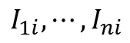 are the elementary indicators for the n_{j} parameters;
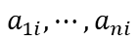 are the weights for each parameter, computing from the PCA loadings, setting each ID grid.
Parameter indexes are estimated using the mode and interquartile range indicators as follows (each indicator is calculated within its environmental unit / classification chain):
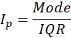
  - The estimation of parameter weights

Probabilistic Principal Component Analysis (e.g., [8,9]) is considered to estimate weights for the elementary parameter indicators. This approach, using the Expectation-Maximization algorithm, is particularly suitable for data in the presence of missing values; it estimates, at each iteration, the maximum likelihood values of missing data (e.g., [10,11]).
Using PPCA, loadings of the first PC are calculated: they represent the weights in the linear combination of the environmental composite indicator. Results are reported in cartographic maps (see Figure 4).
- Conclusions
The environmental composite indicator does not always provide a robust measure; in the presence of many missing data and, if sampling frequency is not nearly uniform, this methodology is not so accurate. However, it could find, for example, a good application in structured environmental monitoring campaigns characterized by invariance of sampling points and by a high sample size.
- Table and figures
Table 1: Samples and parameters by typology - Years 2012-2016 (Source: based on data from Arpa Umbria)
Anno |  | Water | Air | Soil | Sludge and waste | Food | Other | Total
2012 | Samples | 19.010 | 2.907 | 396 | 41 | 186 | 77 | 22.617
2012 | Parameters | 318.742 | 19.724 | 6.047 | 622 | 556 | 700 | 346.391
2013 | Samples | 21.308 | 2.979 | 504 | 57 | 255 | 109 | 25.212
2013 | Parameters | 386.987 | 21.043 | 10.296 | 1.211 | 1.391 | 720 | 421.648
2014 | Samples | 19.850 | 3.564 | 359 | 72 | 300 | 49 | 24.194
2014 | Parameters | 372.421 | 24.931 | 5.274 | 1.417 | 1.961 | 248 | 406.252
2015 | Samples | 20.338 | 3.006 | 497 | 59 | 265 | 20 | 24.185
2015 | Parameters | 386.153 | 25.320 | 14.284 | 2.799 | 923 | 25 | 429.504
2016 | Samples | 20.957 | 2.557 | 285 | 77 | 270 | 13 | 24.159
2016 | Parameters | 428.661 | 21.664 | 8.873 | 3.267 | 865 | 112 | 463.442
Tot. | Samples | 101.463 | 15.013 | 2.041 | 306 | 1.276 | 268 | 120.367
Tot. | Parameters | 1.892.964 | 112.682 | 44.774 | 9.316 | 5.696 | 1.805 | 2.067.237

Figure 1: Example of classification chain for the typology ‘water’ (Source: based on data from Arpa Umbria)
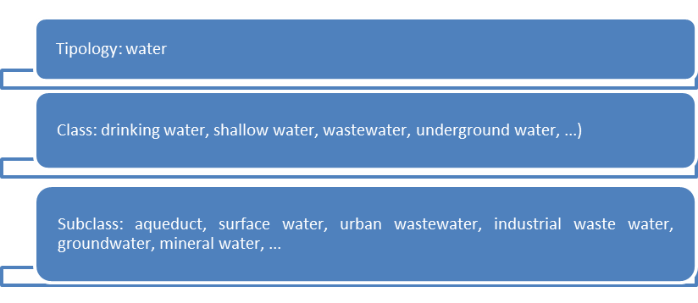

Figure 2: OLAP model for ARPA data mart
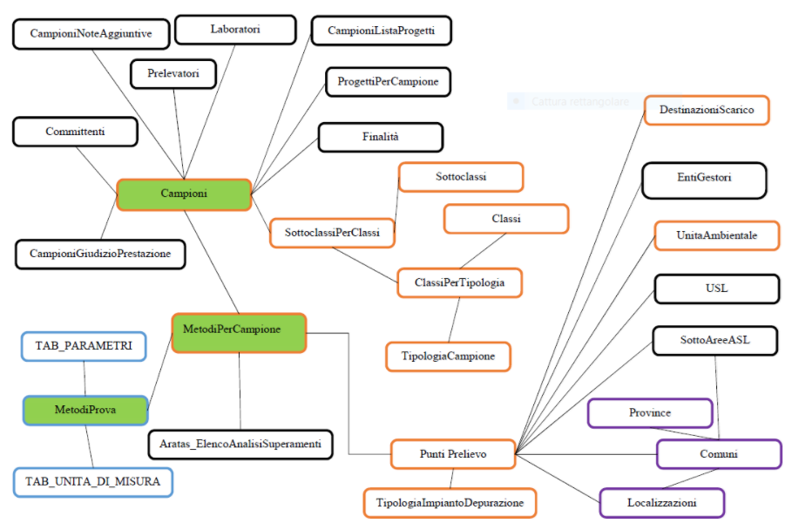

Figure 3: Example of Correlation plot for Agricultural Area unit 2014. 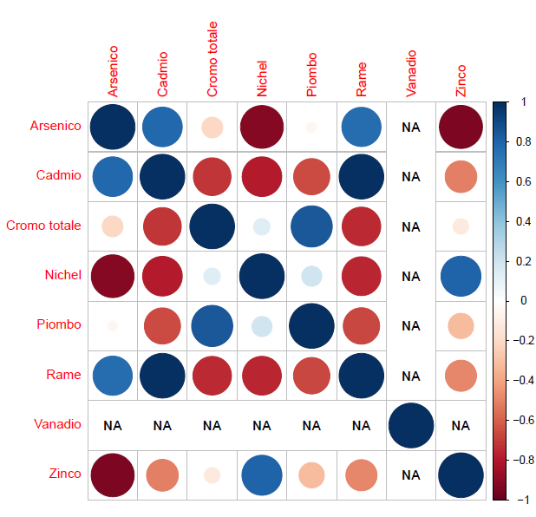 | Figure 4: Cartographic map for the environmental composite indicator2016 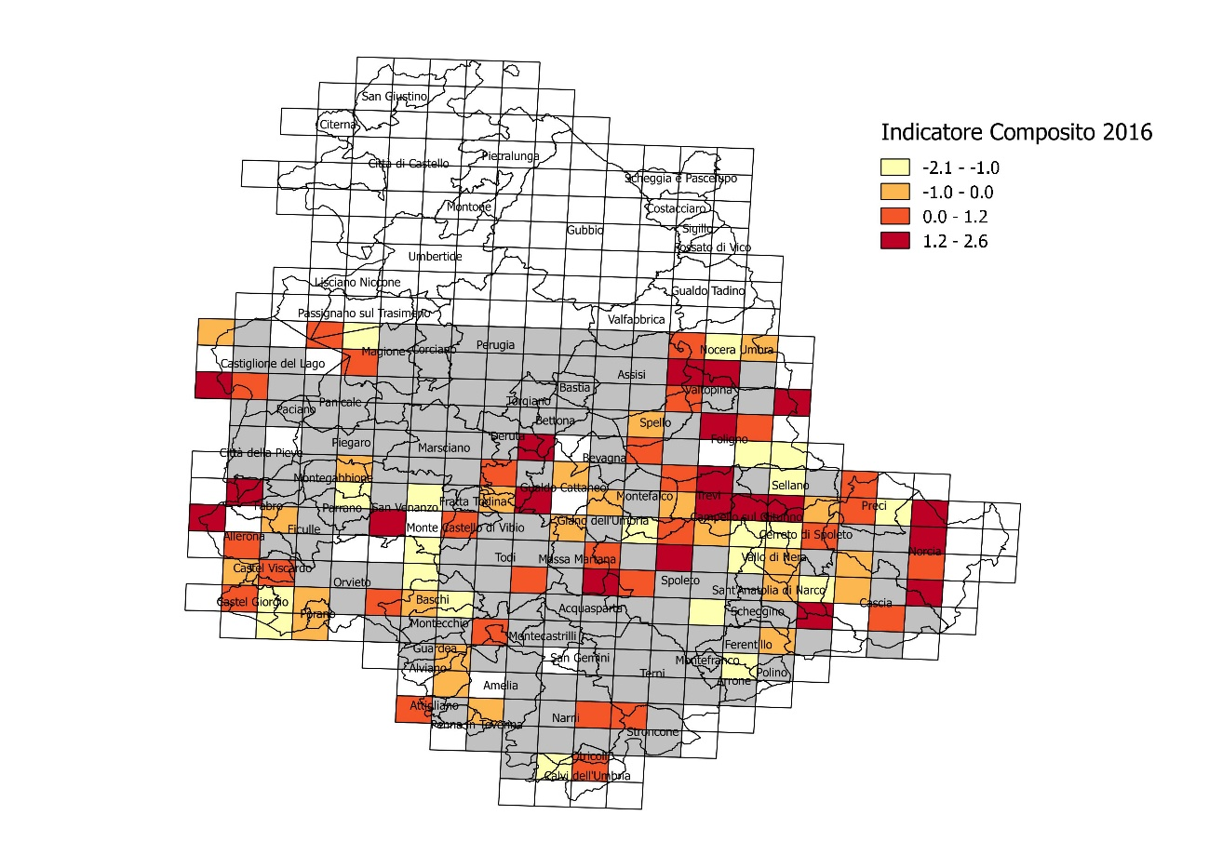
Source: based on data from Arpa Umbria
- References

- E. Bartolucci, M. Bussettini, N. Calace, L. D’Aprile, M. Fratini, M. Guerra, L. Marangio, G. Pirani, A. Vecchio: Protocollo for setting background values for the inorganic substancesin groundwater. ISPRA- Contaminated sites sector, 2009
- Kathryn Z. Guyton, Karen A. Hogan, Cheryl Siegel Scott et al. Human Health Effects of Tetrachloroethylene: Key Findings and Scientific Issues, <<Enviromental Health Perspectives>>, volume 122, number 4, 2014, pp 325-334
- Angelo Martinelli, Paolo Stranieri: Agricultural systems and nitrate pollution. ARPA Umbria, Minutes of the internaziontal conference, Perugia december 11-12, 2003
- M. Angelucci, D. Cappelletti,S. Castellini, M. Galletti, B. Moroni ,C. Petroselli, A. Petrini, A. Pileri, M. Pompei, Caratteristiche morfologiche e chimiche delle polveri sottili in Umbria. ARPA Umbria University of Perugia, Chemistry, Biology and Biotechnology Department and Civil and environmental engineering Department, 2007
- Lorenzo Benini, Lucia Mancini, Simone Manfredi, Serenella Sala, Erwin M. Schau, Rana Pant: Normalisation method and data for Environmental Footprints. European Commission, JRC Technical Report,, 2014
- I. Jolliffe: Principal component analysis, Springer Verlag, New York,1986
- J. Cadima,, & I. Jolliffe: Loadings and correlations in the interpretation of principal components, Journal of Applied Statistics, 22, 203–214, 1995
- Tipping, M. E., & Bishop, C. M.: Probabilistic principal component analysis, Journal of the Royal Statistical Society, 61, 611–622, 1999
- Y. Guan J. Dy: Sparse Probabilistic Principal Component Analysis, Proceedings of the 12th International Conference on Artificial Intelligence and Statistics (AISTATS), Florida, USA, Volume 5 of JMLR, 2009
- S. Roweis: EM algorithms for PCA and sensible PCA (Technical Report). California Institute, 1997
- L. Yu, R. Snapp, T. Ruiz, M. Radermacher: Probabilistic Principal Component Analysis with Expectation Maximization (PPCA-EM) Facilitates Volume Classification and Estimates the Missing Data, National Institute of health, J Struct Biol. 2010 July; 171(1): 18–30. doi:10.1016/j.jsb.2010.04.002.

Marta Bosi, Arpa Umbria; m.bosi@arpa.umbria.it Monica Franzese, IRCCS SDN, mfranzese@sdn.napoli.it Cristiano Trani, Caspur, cristiano.trani@gmail.com Sandra Verduci, Chamber of Commerce of Latina; sandra.verduci@gmail.com

