Heterogeneous effects of subsidies on farms’ performance: a spatial quantile regression analysis
Effetti eterogenei dei sussidi sulle performance delle aziende agricole: un’analisi basata sulla regressione quantilica spaziale
Marusca De Castris and Daniele Di Gennaro
Abstract Italian agricultural sector is characterized by a wide heterogeneity which can affect the effectiveness of rural policies and, by consequence, economic performances. Indeed, wide differences arise both at farm (i.e. sector, dimension, etc.) and regional levels. In particular, Giannakis and Bruggeman (2015) show how agricultural policies can provide enlarge regional disparities between advanced and lagged regions. In this paper, we analyse the differential impact of the policies by considering Italian lagged regions. The introduction of a Spatial Autoregressive Quantile model allows to take into account both spatial and farm-specific characteristic. Evidences are found in favour of significant and positive spatial spillovers of the policies, especially for the less performing farms.
Abstract L’eterogeneità presente nel settore agricolo Italiano può influenzare l’efficacia delle politiche rurali e, conseguentemente, le performance economiche delle aziende. In tal senso, disparità possono emergere in relazioni ai fattori propri delle aziende agricole (settore, dimensione, ecc.) e del contesto regionale. Giannakis e Bruggeman (2015) mostrano come le politiche rurali incrementino le disparità tra aree avanzate ed arretrate. Limitando l’analisi ad alcune regioni del sud, abbiamo analizzato l’impatto differenziale degli incentivi considerando le caratteristiche spaziali delle aziende agricole attraverso una regressione quantilica spaziale. I risultati mostrano esternalità significative e positive delle politiche, soprattutto per le aziende con performance più basse.
Key words: Spatial Quantile Regression, Agricultural Policies, Policy efficacy
- Introduction
This paper aims to evaluate the efficacy of Common Agricultural Policy (CAP) to improve performances by focusing on Italian lagged regions. Agricultural sector is deeply rooted in place-based production processes. The presence of spatial dependence produces biased estimates of the performances. This paper, using data on subsidies and economic results of farms from the RICA dataset, which is part of the Farm Accountancy Data Network (FADN), proposes a spatial Augmented Cobb-Douglas Production Function to evaluate the effects of subsidies on farm’s performances. The major innovation of our study is the implementation of a micro-founded quantile version of a spatial lag model (Kim and Muller, 2004) to examine how the impact of the subsidies may vary across the conditional distribution of agricultural performances. Results show a significant decreasing shape along the distribution of the subsidies which becomes negligible for higher quantiles.

- Data and Methodology
In 2008, EU-27 countries deal with a contraction of agricultural production, in real terms, and a deflationary trend on prices. Additionally, the volatility on both energy and fertilizer markets boosts input prices and contributes to an overall reduction of added value per worker and employment. Under this perspective, Italian case is of particular interest. Italian added value at factor cost increased by 2.4%, while the sectoral share of the GDP remains stable at the 2.3%. However, the good economic performances are not sufficient to reduce the gap between agriculture and the other economic sectors.
Indeed, Italy is characterized by several structural problems which affect agricultural performances. These issues include the presence of systematic differences between North and South, the lack of young farmers (only 13,2 % has less than 44 years) and the land abandonment on marginal areas, especially for high altitude zones.
The gap between North and South appear clear in terms of added value per worker unit. Although Southern regions grow more than the ones in the North (3.5% vs 0.6%), the average added value per worker unit is still well below Italian average (19300 vs 22000 €). In this paper, we consider how the structural weakness of Southern agriculture can affect the efficacy of public support by focusing on the impact of agricultural policies on economic performances. For the year 2008, we exploit information from RICA dataset by introducing five different variables in our analysis. The final dataset is composed by 1298 farms.

Variable | Label | Unit | Description
Value Added | VA | € | Total Revenues-Current Expenses
Labour | L | Unit | Full time worker
Capital Stock | K | € | Land+Agricutltural Fixed Capital
Land | G | Hectares | Utilised Agricultural Area
Subsidies | S | € | Total amount subsidies per farm

In this table we resume all the major determinants on value added formation in the primary sector: Labour, Fixed Capital, Land and Subsidies. The differential impact of all the different variables in determining and stimulating value added is considered by estimating a Cobb-Douglas APF. The dependent variable, value added, is a proxy of economic performances, while subsidies is a composite variable obtained by adding all the amount of the different public instruments allocated to every farm (i.e. we do not distinguish between National or European fund or between policies devoted to current activities, rural development or capital subsidies) and it can be considered as a global indicator of the public capital. In this sense, our baseline takes the form in:
$$ln\left(Y\right)=ln A+α* ln L+β* ln K+ γ* ln G+δ* ln S (1)$$
Checking for the presence of spatial dependence, we found evidences of a significant spatial autocorrelation. In this way, our final model becomes:
$$ln\left(Y\right)=ρW*ln(Y)ln A+α* ln L+β* ln K+ γ* ln G+δ* ln S (2)$$
This equation takes the traditional form of a so-called Spatial Autoregressive Model (SAR). Equation (2) introduces a spatial weight matrix, W. This matrix is based on a cut-off distance (33 km) ensuring the presence of at least one neighbour for every single farm. In this paper, considering the wide heterogeneity between different farms we make use of a Spatial Quantile version of a traditional SAR.
  - Spatial Quantile Regression
Quantile regression is an important method for including heterogeneous effects of covariates on a response variable (Koenker and Hallock, 2001). To include the presence of interactions, the quantile regression generalisation of the (linear) spatial lag model can be written as:
$$Y=ρ\left(τ\right)WY+XB\left(τ\right)+u (3)$$
where $Y=Q_{\left(τ\right)}\left(Y | X\right)$ is the conditional quantile function of Y, $τ$ refers to the selected quantile and $B\left(τ\right)$ is the vector of the sensitivity coefficients of the conditional quantile on changes in value of the covariates X. Estimating spatial quantile regression for different quantiles allows to predict the distribution of the outcome variable at given values of the explanatory variables (McMillen and Shimizu,2017). Equation (3) underlines that the spatial parameter, $ρ$, is dependent from the considered quantile $τ$, allowing for different degree of spatial dependence across the conditional distribution.
In this paper we follow the two-stage estimation procedure in Kim and Muller(2004).This approach were initially developed to control for endogeneity in ''traditional'' quantile regression model, but adjustments to deal with the spatial endogeneity in a Spatial Autoregressive quantile model were straightforward.
On the first step, a variable constituted by the spatial lag of Y (in our case Added Value) is regressed over a set of instruments, as in Equation (4):
$$\hat{WY}=Zθ\left(τ\right)+u, Z =\left[X, WX\right] (4)$$
Instruments are selected following the intuition in Kelejian and Prucha (1998). Low order interactions are needed to avoid linear dependence and retain full column rank of the set of instruments (Baltagi et al. ,2014). At the second stage, the variable $\hat{WY}$ is added on a quantile regression of Y on the X's.
$$Y=ρ\left(τ\right)\hat{WY}+XB\left(τ\right)+u (5)$$
Clearly, $τ$ refers to the same quantile in both equations (4) and (5). The consistency in this approach is guaranteed by estimating differentiated first stages for every quantile considered, while inference based solely on the second-stage of the procedure can be invalid. For this reason, standard errors for the overall two-stage procedure are bootstrapped.
- Results
Results of the spatial autoregressive quantile regression are presented in Table 2 and Figure 1. While in Table 2 we report only the estimates for the tails (0.1 and 0.9) and the median of the distribution, Figure 1 represent the entire conditional distribution of the parameters (i.e. every percentile between 0.01 and 0.99).
In overall, results show that labour (Figure 5) is the major components in fostering economic performances with an elasticity of 0.8. The distribution across the quantiles is pretty stationary, highlighting the independence of labour from the level of economic performances (i.e. homogeneous effects).
Interestingly, fixed capital has a stronger impact in the extremes of the distribution, presents a decreasing shape with a maximum in lowest quantile which turn to increase at the first quartile (i.e. low and high levels of fixed capital influence more economic performances). However, subsidies shows major evidences in favour of the heterogeneity of the effects. This component shows a decreasing shape across all the distribution, with an inflection point in the neighbourhood of the median. Surprisingly, lower levels of subsidies have a greater impact on farm’s performances (+1% of public funding contributes to an increase of 0.4%in added value), while for the upper tail decrease to less than 0.1 and switch to be not significant. Land follows an increasing distributional shape, but it is not significant across all the distribution.
Table 2: Spatial Quantile Regression Estimation
 | Coeff | Z-value | P-Value | Quantile
K | 0.16 | 3.82 | 0.00 | 0.1
L | 0.80 | 13.65 | 0.00
G | -0.05 | -0.89 | 0.37
S | 0.31 | 6.61 | 0.00
Ρ | 0.28 | 2.26 | 0.02
K | 0.15 | 7.19 | 0.00 | 0.5
L | 0.80 | 23.98 | 0.00
G | 0.05 | 2.55 | 0.01
S | 0.14 | 7.79 | 0.00
Ρ | 0.26 | 3.78 | 0.00
K | 0.17 | 5.55 | 0.00 | 0.9
L | 0.81 | 16.88 | 0.00
G | 0.10 | 2.95 | 0.00
S | 0.10 | 3.66 | 0.00
Ρ | 0.31 | 2.98 | 0.00
Note: Estimates are reported in terms of elasticities, while the cut-off distance considered is 33 km.

Figure 1: Spatial Quantile Regression Estimation
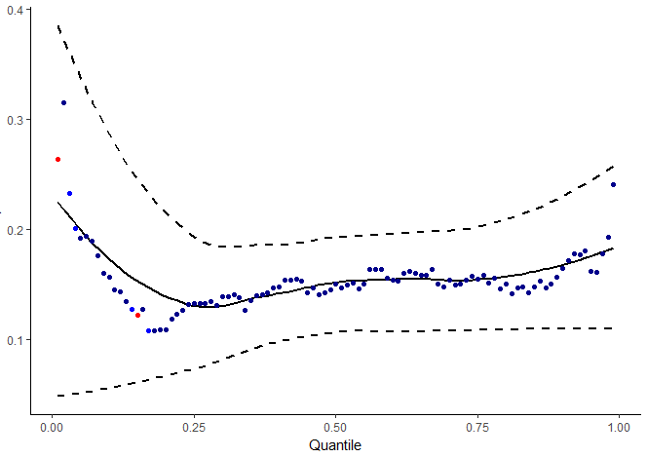(a)  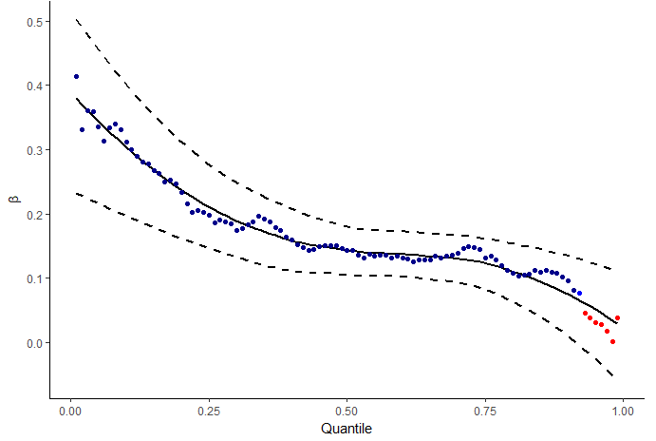(c) | 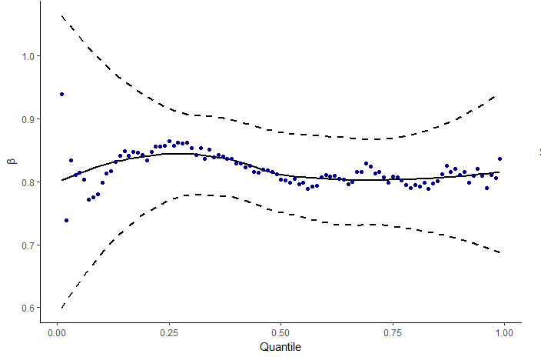(b)  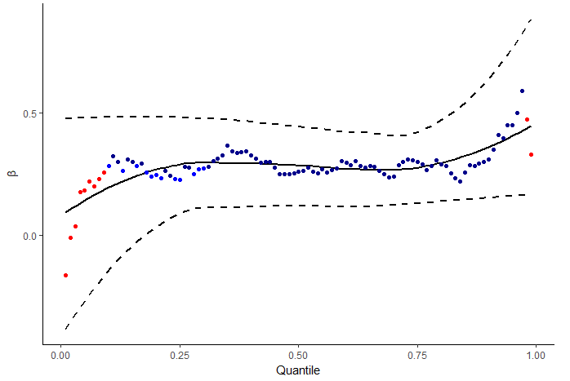(d)
Note: Figure 1 shows the estimates of the Spatial AR model for every quantile. Panel (a) reports estimates for variable K, (b) for L, (c) for S and (d) for $ρ$. The graph for the ground is not reported because of a lack of significance. Solid line represents the smoothed function of the estimates, while dashed lines are the confidence interval at 95%. Statistical significance is reported by different colours: Dark Blue= 0.01, Light Blue= 0.05, Red no significance
Lastly, evidences of significant spillover effects are found. Distributional shape of $ρ$ (Figure 1-d) parameter shows a positive and significant effect on economic performances, even if both lower and upper tails are not meaningful. These results provide clear evidences in favour of the existence of spatial patterns on agricultural activities in Italian lagged regions. However, this parameter is not sufficient to estimate the intensity of the spillover effects. In this sense, we decompose the marginal impacts by following the traditional procedure presented in LeSage and Pace (2009).

Table 3: Marginal Impacts
Marginal Impact | K | L | G | S | Quantile
D | 0.16*** | 0.80*** | -0.05 | 0.31*** | 0.1
 | [3.33] | [15.11] | [-1.00] | [7.55]
I | 0.06 | 0.31 | -0.02 | 0.12
 | [1.56] | [1.64] | [-0.84] | [1.60]
T | 0.22** | 1.12*** | -0.07 | 0.44***
 | [3.05] | [5.22] | [-1.00] | [4.45]
D | 0.15*** | 0.81*** | 0.05 ̊ | 0.14*** | 0.5
 | [7.07] | [24.41] | [1.93] | [6.56]
I | 0.05* | 0.28** | 0.02 | 0.05**
 | [2.26] | [2.50] | [1.41] | [2.69]
T | 0.21*** | 1.08*** | 0.06 ̊ | 0.19***
 | [5.43] | [9.46] | [1.85] | [6.85]
D | 0.17*** | 0.81*** | 0.10** | 0.10*** | 0.9
 | [5.87] | [17.41] | [2.97] | [4.06]
I | 0.07 ̊ | 0.36* | 0.04 ̊ | 0.04 ̊
 | [1.93] | [2.22] | [1.72] | [1.84]
T | 0.24*** | 1.18*** | 0.14** | 0.14***
 | [4.13] | [7.01] | [2.75] | [3.43]
Note: Table 3 presents the results of the decomposition in direct (D), indirect (I) and total effects (T). Q indicates the considered quantile. Estimates are considered in terms of elasticities, while z-values are in square brackets. The z-values and p-values are estimated by Bootstrap.
Statistical significance: *** <0.001, ** 0.01, * 0.05, ̊ 0.1

Spatial quantile regression requires an in-depth analysis for every quantile considered. Table 3 resume the decomposition of the marginal effects for the tails and the median of the conditional distribution. Direct and total effects estimates are positive and significant across all the conditional distribution for all the variables, while results on land are ambiguous and negligible. Nonetheless labour and fixed capital provide evidences of homogeneous effect on the outcome variable conditional to different level of the covariates, we provide evidences of heterogeneous effects for the subsidies.
In detail, the effect of the policies slightly declines for higher quantiles. The wider extension of significant positive effects at the lower quantiles suggests that there is an inverse relationship between subsidies and economic performances. Lower levels of subsidies are devoted to farmers which benefit of agricultural policies as an income maintenance instrument and for which, consequentially, economic performances are mainly affected. Looking at the indirect effects, fixed capital becomes less effective and seems to be not linked to neighbouring characteristics, while positive and significant spillover effects are found in terms of human and public capital. The indirect effects on labour can be explained in terms of favouring qualified labour mobility between neighbouring areas, while the impact on the subsidies is mainly related to structural, environmental and administrative conditions which are in deeply rooted in provincial and regional structure and which can be shared between neighbouring farms.

Conclusions
The heterogeneity arising in Italian agricultural sector can be deeply analysed by a spatial quantile regression model which highlights how both spatial and individual characteristics can influence the performance. Our analysis shows homogeneous effect of farm-specific factors (i.e. labour, fixed capital and land) on economic performance, while heterogeneous impacts of the policies are found, in particular for less performing farms. Evidences of positive and significant spillovers are limited to the inner part of the distribution. In this sense, this paper confirms the hypothesis that actual rural policies are designed as an income support instrument for the farmers.
References
- Baltagi, B. H., Fingleton, B., and Pirotte, A. (2014). Spatial lag models with nested random effects: An instrumental variable procedure with an application to english house prices. Journal of Urban Economics, 80(Supplement C):76 – 86.
- Chernozhukov, V. and Hansen, C. (2006). Instrumental quantile regression inference for structural and treatment effect models. Journal of Econometrics, 132(2):491 – 525.
- Giannakis, E. and Bruggeman, A. (2015). The highly variable economic performance of European agriculture. Land Use Policy, 45(Supplement C):26 – 35.
- Kelejian, H. H. and Prucha, I. (1998). A Generalized Spatial Two-Stage Least Squares Procedure for Estimating a Spatial Autoregressive Model with Autoregressive Disturbances. The Journal of Real Estate Finance and Economics, 17(1):99–121.
- Kim, T.-H. and Muller, C. (2004). Two-stage quantile regression when the first stage is based on quantile regression. Econometrics Journal, 7(1):218–231.
- Koenker, R. and Hallock, K. (2001). Quantile Regression. Journal of Economic Perspectives, 15(4):143–156.
- LeSage, J. and Pace, R. K. (2009). Introduction to Spatial Econometrics. CRC Press.
- McMillen, D. and Shimizu, C. (2017). Decompositions of spatially varying quantile distribution estimates: The rise and fall of Tokyo house prices. Urbana, 51:61801.

Marusca De Castris, Department of Political Sciences, University Roma Tre; email: marusca.decastris@uniroma3.it Daniele Di Gennaro, Department of Political Sciences, University Roma Tre; email: daniele.digennaro@uniroma3.it
Agricultural added value at factor cost per worker unit is 24316 € (44% of the average of Italian economy).
The development gap between North and South is not limited to primary sector. Indeed, regions located in the South of Italy are recognized, by European Commission, as less developed and transition regions. This classification is based on the levels of GDP and employment. Less developed (resp. transition) regions include the areas where GDP per head is less than 75% (resp. between 75 and 90%) of the EU average. The Italian less developed regions are Campania, Apulia, Calabria, Sicily and Basilicata, while transition regions are Abruzzo, Molise and Sardinia. However, we exclude Campania from our analysis for a lack of comparability with the other southern regions, while Abruzzo and Molise are not considered for a lack of information about the farms located in these regions.
Rica is part of the European Farm Accountancy data network (FADN) and it represents the only harmonized survey to collect micro-economic data on firms operating in agricultural. Italian RICA collects information on 11000 farms sampled at regional level. RICA’s field of observation considers only the farm with at least 1 hectare of UAA or a production value greater than 2500 Euros.
Lesage and Pace (2009) provide an in-depth analysis on the estimation of a SAR model and its decomposition of the marginal impacts.
Chernozhukov and Hansen (2006) propose an alternative approach based on a generalisation of the instrumental variables framework to allow for estimation of quantile models.

