Being young and becoming adult abroad: the second generation in Italy and the young Italian emigrants
Essere giovani e diventare adulti all’estero: la seconda generazione in Italia e i giovani emigranti italiani
Cinzia Conti and Enrico Tucci
Abstract The aim of the paper is to analyze the attitude to migrate abroad of Italian and foreign young population living in Italy, the so called “global generations” (Beck, Gernsheim, 2009). The results enlighten a growing mobility for the new generations and also an high propensity among the teenagers to consider a future abroad. An interesting perspective of analysis is offered by the comparison among young people with a international migration background and the young natives . The analysis is based on the data collected through the survey on “the integration of second generations” carried out by Istat in 2015 and on integrated administrative data on migrations and foreign population. Regression models have been used to understand the characteristics the make higher the propensity to imagine an adult life abroad.
Abstract L’obiettivo del lavoro è quello di analizzare l'atteggiamento verso la migrazione all'estero di giovani italiani e stranieri che vivono in Italia, le cosiddette "generazioni globali" (Beck, Gernsheim, 2008). I risultati evidenziano una crescente mobilità per le nuove generazioni e anche un'alta propensione degli adolescenti a considerare un futuro all'estero. Una prospettiva interessante di analisi è offerta dal confronto tra i giovani con un alle spalle una migrazione internazionale e i giovani nati in Italia. L'analisi si basa sui dati raccolti attraverso l'indagine "l'integrazione delle seconde generazioni" realizzata dall'Istat nel 2015 e su dati amministrativi sulle migrazioni e sulla popolazione straniera. Sono stati applicati dei modelli di regressione per comprendere le caratteristiche che rendono più elevata la propensione a immaginare una vita adulta all'estero.

Key words: migrations, second generation, emigrants
- Introduction

In recent years, literature has discussed the characteristics and the behaviours of global or cosmopolitan generations (Beck, Gernsheim, 2009). These are young people characterized, as well as by a wide use of ICT, also by a strong mobility. Consequently mobility can significantly influence the life trajectories of young people (Rizzo, 2016; Frändberg, 2014). Italy is interested in a different way from these new cosmopolitan generations. On the one hand, there are a growing number of young people with migrant background (immigrants or second generation) in the country; on the other, in recent years, there has been a growth of the mobility of young people abroad. The two phenomena can be considered part of a same process of social change

    - Being young abroad
Migrate today is much easier than in the past, especially when you have already experienced migration before. In general, young people, both Italians and foreigners, have shown in recent years a growing propensity to emigrate abroad. Having peaked in 2016 (157 thousand emigrants of whom far more than 50% is between 15 and 34), the number of emigrants is continuously on the increase since 2007. The growing propensity of young people to go abroad is also highlighted by some surveys such as the one concerning the professional insertion of research doctors, for whom the percentage of those living abroad at the time of the interview (2014) is close to 13% (+6 points compared to the 2009 edition).
    - Emigration flows between 2006 and 2015
According to the available information and administrative sources, it is possible to take in to account the composition and the trends of both emigration stock and flows of Italian citizens. In this section we used flow data coming from the Italian population registers (Anagrafi) locally kept by the municipalities. As a matter of fact, the change of residences are collected by means of the APR.4. administrative form (introduced from 1 January 1992 with the circular Istat n. 56 of 30 October 1991). The form has been used for statistical purposes, as well as administrative,and must be used to define the individual residence of both Italian and foreign citizens. It must be completed to define changes of residence between municipalities, to document registrations and cancellations to / from abroad and for other reasons and communication to Istat. It includes information on the origin and destination of the movement as well as the main demographic characteristic of the migrant such as sex, marital status, data and place of birth, educational attainment, etc.
The Italian population registers collected a total of 901 thousand emigration from Italy between 2006 and 2015 (Tab.1). Among these, there were 592 thousand of emigrants with the Italian citizenship (66% of the total emigration). The 38,9% of the emigrantas were aged between 15 and 34 years. The percentage of young people is larger among nationals (40.3%) than among Non-nationals (36.0%).

Table 1: Emigrants by citizenship (National/Non national). Years 2006-2015, absolute values and percentages
Year | Nationals |  | Non Nationals |  | Total
 | a.v. | Percentage aged 15-34 | a.v. | Percentage aged 15-34 | a.v. | Percentage aged 15-34
2006 | 46,308 | 36.9 | 12,099 | 37.3 | 58,407 | 37.0
2007 | 36,299 | 40.6 | 14,814 | 39.4 | 51,113 | 40.2
2008 | 39,536 | 41.5 | 22,135 | 40.4 | 61,671 | 41.1
2009 | 39,024 | 41.7 | 25,897 | 39.8 | 64,921 | 40.9
2010 | 39,545 | 40.1 | 27,956 | 36.5 | 67,501 | 38.6
2011 | 50,057 | 39.4 | 32,404 | 35.5 | 82,461 | 37.9
2012 | 67,998 | 38.3 | 38,218 | 37.0 | 106,216 | 37.9
2013 | 82,095 | 41.0 | 43,640 | 33.5 | 125,735 | 38.4
2014 | 88,859 | 41.1 | 47,469 | 34.1 | 136,328 | 38.7
2015 | 102,259 | 41.5 | 44,696 | 34.0 | 146,955 | 39.2
Total | 591,980 | 40.3 | 309,328 | 36.0 | 901,308 | 38.9
Fonte: Istat, 2015.

During this period, Lombardy reported the largest number of Italian emigrants (109 thousand), followed by the Sicily (59 thousand), Lazio (57 thousand) and Veneto (55 thousand). The regions that reported the highest percentage of young emigrants were Sardegna (51,6%) and Puglia (46,0%).
Between 2006 and 2015, 144 thousand emigrants were born abroad (one out of four). Among these 144 thousand, the largest number of emigrants was born in Brazil (26 thousand), followed by Germany (20 thousand), Switzerland (11 thousand) and Morocco (7 thousand). On the contrary, if we consider the other specific subgroup of native born with Italian citizenship, an analysis by next residence reveals that Germany is the favourite country of destination (72 thousand), followed by Great Britain (63 thousand).
Regarding the gender distribution of emigrants, there were more men than women (57 % compared with 43 %). The gender distribution is more balanced in the young ages where, between 15 and 34 years of age, the share of male is equal to 55,7% (Fig.1).

Figure 1: Age structure of emigrants. Age at the event. Years 2006-2015
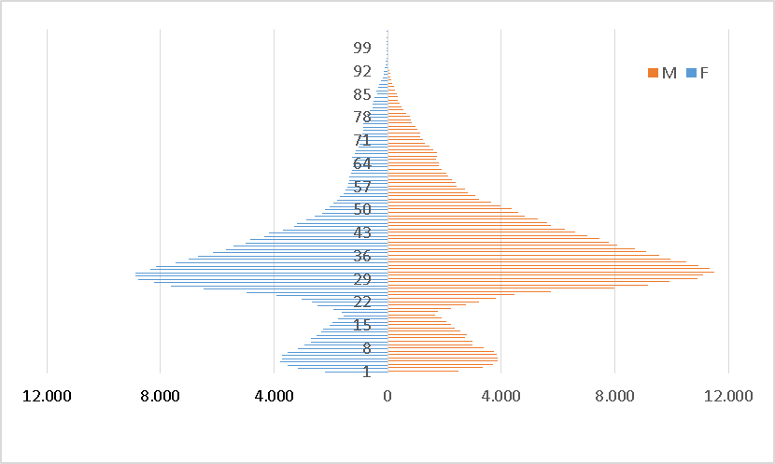
Fonte: Istat, 2015.

Almost 2 out of 3 Italian emigrants, native born, between 15 and 34 years of age (184 thousand people in total) chose? as a destination one of these five countries: Great Britain (35 thousand), Germany (30 thounsand), Switzerland (21 thounsand), France (17 thounsand) and United States (12 thousand). An analysis by educational attainment of this specific subgroup reveals that the majority (60.5%) of the emigrants have completed at least the upper secondary school, while one out of four have at least a bachelor degree. This percentage raises over 30% for countries such as United States, Netherlands, Irland, China, Luxemburg and United Arab Emirates.
- Italians abroad: the contribution of young generations
In this section we process administrative data collected by Ministry of Foreign Affairs and International Cooperation. The information available is related to the consular archives of Italian citizens and their families that reside abroad. The quality of the information included in this database has significantly increased since Article. 5 of the Law n. 459 of 27 December 2001 establishes that the Government provides the electoral list of Italian citizens residing abroad through the comparison between the data of Italians residing abroad (Ministry of Interior) and of the consular archives (Ministry of Foreign Affairs and International Cooperation). The latter includes the main socio-demographic characteristics of the individual such as age, sex, marital status, place of birth and the educational attainment. There were 5.2 million Italian citizens residing outside Italy on 1 January 2016.
In absolute terms, the largest numbers of nationals living abroad on 1 January 2016 were found in Argentina (898 thousand persons), Germany (740 thousand), Switzerland (607 thousand), Brazil (454 thousand) and France (392 thousand). Nationals in these five countries collectively represented 60 % of the total number of nationals living abroad. Only 1.6 million of Italians living abroad (31,2%) was born in Italy.
In relative terms, the country of residence with the highest share of native born was United States, as they accounted for 53,3 % of its total Italian population. A high proportion of native born (more than 40 % of the Italian resident population) was also observed in Canada, Great Britain, Germany, France and Netherlands. By contrast, a low proportion of native born (less than 10 % of the Italian resident population) was observed in Chile (4%), Uruguay (5,4%) and Brazil (8%).

Figure 2: Age pyramid of Italian citizens permanently living abroad. 1st January 2016

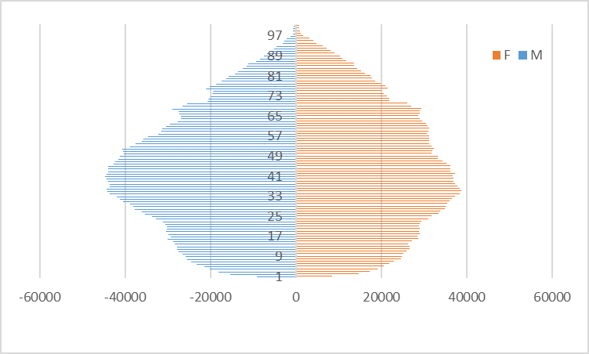
Fonte: Istat, 2015.

An analysis of the age structure of the population shows a greater proportion of relatively young working age adults. On 1 January 2017, the modal age was 40 years for males and 34 for females, while the median age of nationals living abroad was 43 years (Fig.2).
The number of Italian living abroad, born in Italy and between 15 and 34 years of age on 1st January 2016 was 183 thousand. Germany had the highest number, at 40 thousand (or 21.3% of the total). The next highest levels of young Italian residents were recorded in Great Britain (32 thousand), Switzerland (22 thousand), and France (17 thousand).
In relative terms, the country of residence with the highest share of young Italian with at least a upper secondary degree, was United Arab Emirates, as they accounted for 93,8 % of its total young Italian population. A high proportion (more than 85 % of the Italian resident population) was also observed in Netherlands Luxemburg, Great Britain.
- Mobility intentions of young people: Italian and foreign citizens compared
In Italy, at 1 January 2017, the population aged between 15 and 34 is 12,608,057, of whom almost 13% have foreign citizenship. Children with migratory background would be many more taking into account those who have acquired Italian citizenship. Between 2011 and 2016, around 250,000 minors acquired Italian citizenship. Also counting the "new citizens", the second generation would therefore have even greater importance. It is clear that young people with migratory background has a relevant demographic incidence on the new generations.
In this context, it is important to try to understand in perspective the intentions of the very young of today, both Italians and foreigners. The change in the sense of "citizenship" and "belonging" does not only affect the children of immigrants, but in general the younger generations and it is therefore interesting to try to understand if some attitudes are typical of young children of foreigners or, in a more extended way, of the young people who live in our country.
In 2015 Istat carried out the survey on “Integration of the second generation” (ISG) co-financed by the Ministry of Interior and the European Union European Fund for the Integration of Third-Country Nationals (Istat, 2016a and Istat 2016b). The survey is based on a sample of secondary schools with at least 5 foreign pupils. The interviewed students are aged between 11 and 19 years. The survey aims to study the second generation in the broader sense and therefore, more properly, the kids with a migratory background. The main target of the survey was therefore the children with a different citizenship than the Italian one. It should be emphasized that, in accordance with Italian law, foreign children are also considered foreigners born in Italy by foreign parents The survey had as a further target: control group of students with Italian citizenship.
The results of the survey underline that both for foreigners and for Italians there is a considerable proportion of young people who want to live abroad, respectively 46.5 percent and 42.6 percent. These are very high percentages that confirm that these generations perceive the idea of moving abroad in a different way from those of the past. One might expect that for children who are not born in Italy there is a desire to return to their country of origin; in reality, even for them, whatever the migratory generation, the desire to live in another state prevails. It is the United States that most attracts all young people, regardless of citizenship (30.1 percent); followed by the United Kingdom (10.7 percent) and Germany (10.0 percent). Considering only foreign children born in Italy, the situation is strongly diversified by country of citizenship (Tab.2).
The share of those who want to live in our country as adults is higher in the Moldovan (49.4 percent) and Ukrainian (46.1 percent). The propensity to remain in Italy is not necessarily connected with "feeling Italian". For example, in the case of China, in the face of a small proportion of young people who claim to feel Italian, high percentages of young people want to live in our country both among those born in Italy and among those born abroad. Over six Indian boys out of ten wish to live abroad as adults. Moroccans (51.6 percent), Filipinos (51.4 percent) and Albanians (45.8 percent) also prefer another country for future life. In general, pupils who are not born in Italy prefer "another foreign state", with the exception of the Chinese who choose their country of origin in most cases (44.0 percent), even if the proportion of those who plan a life in Italy. It is confirmed that, on equal terms, 45 foreigners - especially those born abroad - show a propensity to want to live in Italy from very large adults compared to Italians. Girls are less likely than boys to want to stay in Italy.

Table 2: Foreign students born in Italy and abroad, place where they would like to live as adult, citizenships – Year 2015, percentages

Citizenship | Born in Italy |  |  |  |  |  | Born abroad
Citizenship | In Italy | In the country where one of my parents was born | Abroad in another country |  |  |  |  | In Italy |  | In the country where I was born |  | Abroad in another country |  | Abroad in another country
Albania | 40,0 | 14,3 |  | 45,8 |  |  | 29,3 |  | 15,1 |  | 1,8 |  | 53,8
Romania | 35,7 | 19,4 |  | 44,9 |  |  | 29,9 |  | 18,8 |  | 2,1 |  | 49,1
Ukraine | 46,1 | 7,5 |  | 46,4 |  |  | 40,6 |  | 15,3 |  | 0,8 |  | 43,4
Moldova | 49,4 | 13,2 |  | 37,4 |  |  | 31,8 |  | 11,7 |  | 0,9 |  | 55,5
China | 48,6 | 24,7 |  | 26,7 |  |  | 39,3 |  | 44,0 |  | 5,7 |  | 11,0
Philippine | 31,5 | 17,1 |  | 51,4 |  |  | 22,7 |  | 31,8 |  | 3,4 |  | 42,1
India | 34,2 | 5,6 |  | 60,2 |  |  | 29,7 |  | 17,8 |  | 5,3 |  | 47,1
Morocco | 34,5 | 13,9 |  | 51,6 |  |  | 29,3 |  | 20,6 |  | 3,9 |  | 46,1
Ecuador | 38,4 | 29,6 |  | 32,0 |  |  | 22,7 |  | 25,0 |  | 1,9 |  | 50,4
Peru | 33,5 | 28,2 |  | 38,3 |  |  | 25,3 |  | 27,2 |  | 2,6 |  | 44,9
Fonte: Istat, 2015.

A lower propensity is also shown by those who feel in conditions of economic hardship, from high school students (especially high schools) and from residents in the Center and North. By limiting the analysis to foreign students only, the propensity to remain in Italy was assessed, further investigating other characteristic aspects of migrants. Who has a better knowledge of the Italian language, who has declared to be Italian and who frequents Italian or Italian and foreign friends is more inclined to want to live in Italy, a sign that the substantial citizenship and the sense of belonging are also constituted by relationships social. A lower propensity to remain in our country is instead associated with foreigners born abroad and entered Italy within 10 years.46 Considering, finally, the first four citizens, the Chinese students are the most likely to want to live as adults in Italy; Albanian, Moroccans, Romanian and “other citizens” compared to the Chinese have a much lower propensity to stay in Italy. This evidence underlines again how migratory models are peculiar to the various communities, even in the case of second generations. The Chinese community, even if it is one of the most “closed”, both in terms of relations and frequentation with Italians, and with respect to the sense of belonging, is actually the one that, even on equal terms, wants to continue living in Italy.

References
- Beck U., Beck-Gernsheim: Global Generations and the Trap of Methodological Nationalism For a Cosmopolitan Turn in the Sociology of Youth and Generation In “European Sociological review”, vol. 25 Issue 1 (2009)
- Frändberg L.: Temporary Transnational Youth Migration and its Mobility Links. In “Mobilities”, (2014,) vol. 9:1, 146-164.
- Istat, Rapporto Annuale. La situazione del Paese (2016).
- Istat, L’integrazione scolastica e sociale delle seconde generazioni, (2015).
- Rizzo C.: Le dimensioni del cosmopolitismo. Un'indagine tra i giovani del Servizio Volontario Europeo, Franco Angeli, Roma, (2016)

Cinzia Conti, Istat, ciconti@istat.it Enrico Tucci, Istat, tucci@istat.it

