What Shapes Population Age Structures in the Long Run
Verso dove tende la struttura per età corrente
Gustavo De Santis and Giambattista Salinari
Abstract We present and test a hypothesis that, to the best of our knowledge, is new in the demographic field: the age structure of any population in any period tends towards a specific shape, which can be identified in advance. This “attractor” is the age structure of the current stationary population, which we label RAS, or “reference age structure”. There is no mathematical demonstration for this tendency: however, we show that it exists in practice, measure the speed of the convergence (of the current on the reference age structure), and discuss the theoretical and practical utility of the notion.
Abstract In questo paper dimostriamo che la struttura per età corrente evolve nel tempo subendo la costante attrazione della struttura per età della popolazione stazionaria corrente, che qui chiamiamo RAS (“reference age structure”, o struttura per età di riferimento). La tendenza alla convergenza non può essere dimostrata matematicamente, ma avviene empiricamente: qui lo si dimostra, si misura la velocità di questo processo e si discutono alcune delle implicazioni teoriche e pratiche della nostra scoperta, che, a quanto ci consta, rappresenta una novità in demografia

Key words: Age structure, Stationary population, ECM (Error Correction Model).
Two Age Structures: Actual and Stationary Populations
Let c_{x,t} be the age structure of the population at time t, or current age structure. It is defined as the relative share of population aged x, P_{x}, to the total population P: c_{x}=P_{x}/P. Similarly, let k_{x,t} be the age structure of the stationary population, calculated on the cross sectional life table in year t. If L_{x,t} are the person-years lived at age x in year t and T_{0,t} is their sum, or total number of person-years lived at all ages, the ratios k_{x,t}=L_{x,t}/T₀,t form the age structure of the stationary population in year t, which we also call “reference” age structure (or RAS) in this paper. Obviously, Σc_{x}=Σk_{x}=1. Selected examples of both are presented in Figure 1.

Figure 1: Actual (c_{x}) and reference (k_{x}) age structures of selected populations
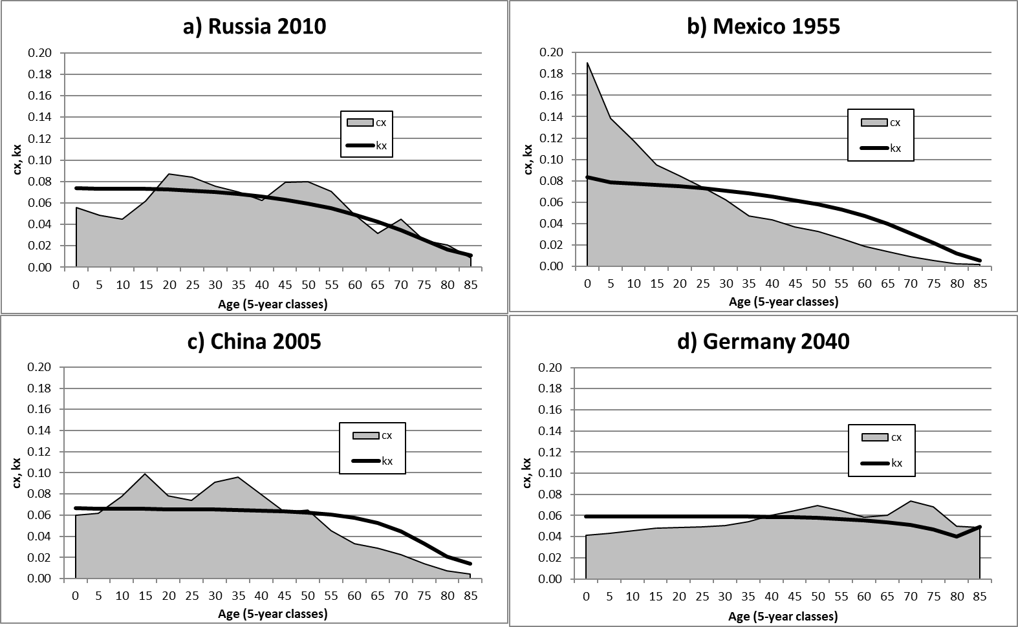
Source: UN (2017).

Our hypothesis is that the shares c_{x,t} tend to move towards their reference counterpart k_{x,t}. To prove this, we run the following Error Correction Model (ECM) on UN (2017) data
Δc_{x,t} = β₀ + β₁ Δk_{x,t} + β₂ (k_{x,t-1}-c_{x,t-1}) + ε_{x,t} (1)
where Δc_{x,t}=c_{x,t}-c_{x,t-1}, Δk_{x,t}=k_{x,t}-k_{x,t-1}, and ε_{x,t} is the error term. Our main object of interest is the coefficient β₂, which we expect to be significantly greater than zero. If this is true, the c_{x,t} series tends to converge on the k_{x,t} series. Figure 2, where we drew the profiles of the actual and of the reference age structure at time t-1 of a hypothetical population, gives a visual representation of what we expect will happen.
Figure 2: Hypothesised dynamic of the population structure
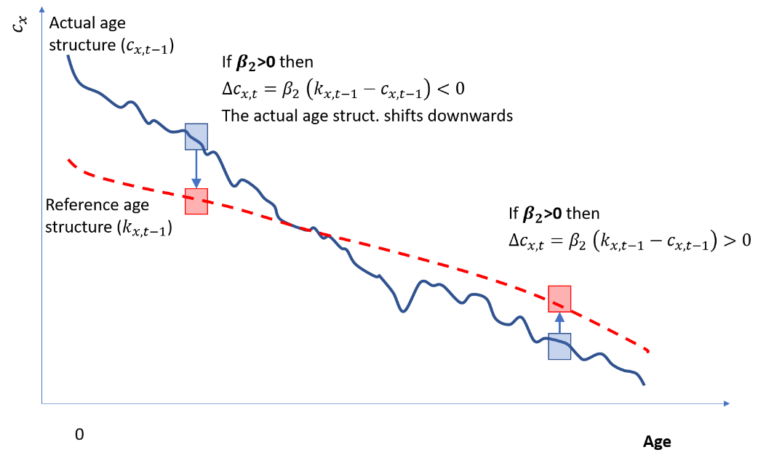
Source: Illustrative data.
Data and Empirical Results
The main results of our model, based on the most recent UN (2017) data and estimates, are presented in Table 1. Note, first, that each country provides 204 observations: 17 five-year age classes (0-4 to 80-84; while the last, open-ended one, 85 and over, is not used in the estimates) for 12 five-year periods (1950 to 2015; this makes 13, but we “lose” one, because we work on differences).
The estimates of β₂ are positive and significant in all of the world and in almost all of its (sub)regions. The only exception is Middle Africa, and the reason why this happens is, we submit, the fact that this part of the world is still going through its demographic transition, which is strong enough to obscure the underlying tendency (convergence of c_{x} on k_{x}) that we are focusing on here. The speed of convergence ranges between 2% and 40%, depending on the region, and is about 6% at world level. In other words, on average, 6% of the difference between k_{x,t} (reference age structure) and c_{x,t} (actual age structure) observed in year t disappears 5 years later, because the current age structure tends to move in the “right” direction (see again Figures 1 and 2), which is precisely what we wanted to prove.

Table 1: Estimates of equation (1) by UN sub-regions
SubRegion | #Countries | Obs. | Intercept | β₁ | β₂ | R²
World | 201 | 41004 | -2.36E-05 | -0.261* | 0.062* | 0.06
Africa
Eastern Africa | 20 | 4080 | -8.50E-06 | -0.183* | 0.024* | 0.02
Middle Africa | 9 | 1836 | -1.20E-05 | -0.336* | 0.002 | 0.01
Northern Africa | 7 | 1428 | -3.49E-05 | -0.943* | 0.078* | 0.09
Southern Africa | 5 | 1020 | 1.58E-06 | -0.004 | 0.024* | 0.03
Western Africa | 16 | 3264 | -7.30E-06 | -0.380* | 0.015* | 0.02
America
Caribbean | 17 | 3468 | -6.62E-05 | -0.814* | 0.113* | 0.12
Central America | 8 | 1632 | -7.48E-05 | -0.783* | 0.063* | 0.14
Northern America | 2 | 408 | -7.84E-05 | -0.920* | 0.165* | 0.14
South America | 13 | 2652 | -8.56E-05 | -0.985* | 0.078* | 0.15
Asia
Eastern Asia | 8 | 1632 | -4.56E-05 | -0.674* | 0.182* | 0.13
South Central Asia | 14 | 2856 | -1.09E-05 | -0.634* | 0.074* | 0.06
South Eastern Asia | 11 | 2244 | 8.02E-06 | -0.130* | 0.074* | 0.09
Western Asia | 18 | 3672 | -5.86E-05 | -1.257* | 0.077* | 0.06
Europe
Eastern Europe | 10 | 2040 | 3.78E-05 | -0.107 | 0.406* | 0.23
Northern Europe | 11 | 2244 | 4.25E-06 | 0.061 | 0.202* | 0.13
Southern Europe | 12 | 2448 | -2.39E-05 | -0.254* | 0.188* | 0.16
Western Europe | 7 | 1428 | -4.17E-05 | -0.434* | 0.317* | 0.17
Oceania
Australia New Zealand | 2 | 408 | -5.42E-05 | -0.536* | 0.138* | 0.13
Melanesia | 5 | 1020 | -4.09E-05 | -1.038* | 0.075* | 0.14
Micronesia | 3 | 612 | -6.30E-05 | -1.727* | 0.089* | 0.09
Polynesia | 3 | 612 | -4.26E-05 | -0.676* | 0.082* | 0.11
Source: Own calculations on UN data. The parameters in red are non-significant (α=5%).

To the best of our knowledge, this tendency had thus far gone unnoticed in the literature. We venture that there are two main reasons why this happened. The first is that this convergence cannot be proved mathematically. Indeed, the reverse is true: there are theoretical cases (not discussed here) in which it can be proved that convergence does not take place. The second reason is that convergence is a constant, but weak force, as our estimates of Table 1 indicate, which is easily obscured by others, such as strong migration flows, or the demographic transition. In the long run, however, or with a sufficient number of observations on data of reasonable quality, this tendency emerges and can be detected.
On the Distance Between the Actual and the Reference Age Structure
The distance between the actual (c_{x,t}) and the reference age structure (k_{x,t}) can be measured with the index of dissimilarity D_{t}, which indicates what share of the population should be in a different age class to result in a perfect coincidence between the two (c_{x} and k_{x}), in year t
$D_{t}=\frac{1}{2}\sum_{c}{\left|c_{x,t}-k_{x,t}\right|}=\frac{1}{2}\sum_{c}{\left|\frac{P_{x,t}}{P_{t}}-\frac{L_{x,t}}{T_{0,t}}\right|}$ (2)
By construction, D_{t} ranges between 0 and 1, but in practice, it is virtually impossible in this kind of application (population shares by age classes) to find D_{t} outside the range 5-50% (discussion skipped here). Figure 3 shows that D_{t} (dissimilarity, or distance) has not decreased monotonically in the past 65 years, as our model (1) predicts: we argue that this is due to the fact that, in the “short” run, other forces prevail, first of all the demographic transition.

Figure 3: Dissimilarity index D_{t} between the actual (c_{t}) and the reference (k_{t}) age structure in selected world areas, 1950-2015
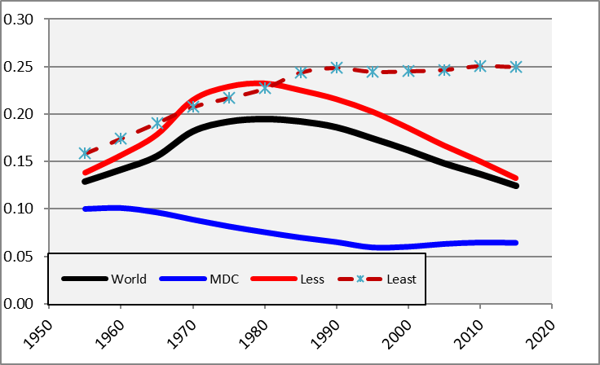
Note: MDC=More Developed Countries; Less/Least=Less/Least Developed Countries
Source: UN (2017) and own calculations.

Indeed, in more developed countries (whose demographic transition took place in the late 19th-early 20th century, i.e., left of the time scale displayed in Figure 3), D_{t} does decrease over time and is today about as low as it can reasonably be. In less developed countries, D_{t} increased until the 1980s (precisely because of the biases produced by the ongoing demographic transition following WW2) and decreased later. In the least developed countries (basically, Sub-Saharan Africa) convergence is not yet taking place, and the two age structures (c_{x,t} and k_{x,t}) remain far from each other. (Convergence will occur in the next decades, according to the UN Projections, but this is not shown or discussed here.)
So what?
Our finding has several important implications, which we cannot fully develop here, for reasons of space. For instance, it affects the ongoing debate on the main causes of population ageing: is it (mainly) due to low fertility or low mortality? Our answer is simple: as the current age structure c_{x,t} tends to “move” towards its reference counterpart k_{x,t}, which depends exclusively on survival, lower mortality is the underlying force that (slowly) drives the process of population ageing. Deviations from this path can be important, and they can last for some years, or even decades, but eventually the “attraction” of k_{x,t} (i.e., the dominant role of the mortality regime) prevails.
A second application (among others) is in the field of pension systems. Our finding suggests that pension systems should be designed giving emphasis to the reference age structure k_{x,t} and to its evolution over time, as the current age structure c_{x,t} will eventually converge towards it. This takes time, admittedly, but pension systems are, or at least should be, intended to last for very many years: to base them on the reference age structure k_{x,t} would make them much more long-lasting and robust than they usually are.
Acknowledgements
We thank the CREW group for early feedback on this paper (CREW=Care, Retirement and Wellbeing of Older People across Different Welfare Regimes; https://crew-more-years-better-lives.org/).
References
- UN. 2017. World population prospects, Population Division, Department of Economic and Social Affairs, New York

Gustavo De Santis, University of Florence; email: gustavo.desantis@unifi.it; Giambattista Salinari, University of Sassari; email: gsalinari@uniss.it.

