Mortality trends in Sardinia 1992-2015: an ecological study
Evoluzione della mortalità in Sardegna 1992-2015: uno studio ecologico
Vanessa Santos Sanchez, Gabriele Ruiu Marco Breschi, Lucia Pozzi
Abstract Sardinia has been for long times under the lens of biologists, demographers and social scientists for the high longevity of the population of some of its territories. However, and in some sense paradoxically, the island represents an ideal context to study the effect on human mortality produced by the environmental deterioration caused by the settlement of heavy industry. By the means of a spatial analysis we found that the largest increase in mortality rates in the period 1992-2015 are indeed in industrial areas.
Abstract La Sardegna è stata per lungo tempo analizzata in ambito demografico, biologico e sociologico a causa della longevità registrata nelle popolazioni di alcuni suoi territori. Paradossalmente, questa regione rappresenta però un contesto ideale per studiare l’effetto prodotto sulla salute umana dalla presenza di industria pesante. Usando tecniche di analisi spaziale, si mostra infatti che il più alto incremento nei tassi di mortalità nel periodo 1992-2015 ha caratterizzato proprio le zone industrializzate.
Key words: Mortality, Spatial epidemiology, Sardinia.
- Introduction
[1] coined the expression “blue zone of longevity” (from hereon BZL) for indicating a rather limited and homogenous geographical area where the population shares the same lifestyle and environment and its longevity has been proved to be exceptionally high. Ogliastra (South-Eastern Sardinia, Italy) together with a small number of regions around the World has been acknowledged as a BZL. The peculiar characteristic of the blue zone individuated in Sardinia, is that among centenarians the female/male ratio is about 1.34 which is a value considerably lower than in the rest of Italy ([2]). This has obviously attracted many research efforts for trying to explain the extraordinary longevity of males ([3]) whilst, at least in recent time, less attention has been devoted to analysing the overall evolution of mortality in Sardinia. Generally, the Italian public considers Sardinia a place where the environmental conditions and the healthy diet have favoured male longevity. However, this is far from being true at least in some zones of the island. In particular, Sardinia represents an ideal context for studying the effect that highly polluting industrial sites, mining sites and military bases play on human health. To our knowledge, only [4] analysed the Sardinian age-standardized mortality rates, at the municipal level, for a quite short period (1997-2001) finding that among males it was higher than in Italy (84.4 vs 80.8) while the reverse occurred in females (50.9 vs 52.0). They also find that the industrial sites of Porto Torres (chemical plants were established in this Northern Sardinian city during the sixties) was characterized by an excess mortality for respiratory diseases, diseases of the digestive tract, liver cancer and lymphohaemopoietic cancer. An anomalously high incidence of lymphohaemopoietic cancer was found also among the population living near military sites (La Maddalena, Salto di Quirra). An excess of deaths for respiratory related problems was also found in other industrial zones (Portoscuso and Sarroch). We enlarge their analysis to capture the evolution of mortality from 1992 to 2015 and applying a spatial methodology originally proposed by [5]. Extending the time period allows establishing when the pollution related to industrial activity which initially hit men, because of the fact that the workforce in these sectors is almost entirely composed by males, has begun to affect also female population, thus denoting a deterioration of the environmental conditions.
  - Data and Methods
An ecological study of small areas was carried out for the 377 Sardinian municipalities existing in 2015, in the periods 1992-1997, 1998-2003, 2004-2009 and 2010-2015. Individual death entries for the period 1992-2015, broken down by municipality and sex, were used as case source.
Municipal populations, broken down by age group (20 five-years groups) and sex are obtained for each year. The person years for each period were calculated by adding the population of each year.
Mortality and population data have been derived from ISTAT database.
We used the 2001 deprivation index created by [6] as indicator of socioeconomic level. This index classifies municipalities into 5 levels, according to several variables: (i) low level of education, (ii) unemployment, (iii) non-home ownership, (iv) one parent family and (v) overcrowding. This classification is based on the quintiles of the distribution of factor scores, where level 1 municipalities are the richest ones and level 5 municipalities the least rich ones.
To calculate the number of expected cases, overall Sardinian specific age group, sex and period mortality rates were multiplied by each municipal person-years for the same age, sex and period pattern. Standardized mortality ratios (SMRs) were calculated as the ratio of observed to expected deaths.
Smoothed municipal relative risks (RRs) with their corresponding 95% credibility intervals, were calculated using the conditional autoregressive model proposed by [5]. This model fits a Poisson spatial model with two types of random effects, a non structured effect that takes into account the municipal heterogeneity, and a structured effect, the spatial term, that considers municipal contiguity. To define area contiguity we used the adjacent municipal boundaries.
The model takes the following form:

~

Where λ_{i} is the RR in area i, O_{i} is the number of observed cases, E_{i} is the number of expected cases, α is the intercept, h_{i} is the municipal heterogeneity and b_{i} is the spatial term.
To analyze the effect of deprivation on mortality, the index proposed by [6] was included in the models as a covariate.
The Bayesian estimation of the models was obtained using Markov Chain Monte Carlo (MCMC) simulation methods, through the Gibbs Sampling algorithm via free distribution software WinBUGS. Convergence of the estimators was achieved before 100.000 iterations for three Markov chains, with a burn-in of 10.000 iterations. The convergence was ensured by the algorithm proposed by [7] and the effective sample size of chains.
The free software R was used to create municipal maps of SMRs, smoothed RR estimates and posterior probabilities that smoothed RR was greater than one (PRPs). To calculate PRPs we used the criterion proposed by [8], considering PRPs greater than 0.8 as statistically significant.
- Results
From 1992 to 2015 a total of 343,584 deaths was registered in Sardinia, 182,993 in men (53.3%) and 160,591 in women (46.7%).
We did not observe any prevailing geographical mortality pattern in RRs for mortality throughout the 24 years of the study in either women or men.
For men, in the third period, municipalities in the northeastern provinces of Sassari, Olbia and Nuoro show an excess of mortality, with some RRs greater than 1.50 (municipalities of Sennariolo and Sagama). Figure 1 (panel a,b,c, d) shows the maps depicting the municipal distribution of mortality for each period for men.
In a different way, for women, in the last two periods, the municipalities of La Maddalena, Osilo and Ploaghe remain as the areas with the highest RRs, between 1.10 and 1.25.
Figure 2 (panel a, b, c, d) depicts the spatial pattern of the posterior probability of RR being greater than one for women. Municipalities with a statistically significant excess risk are shown in orange and areas with a low risk are shown in blue.
A high-risk pattern is observed in the province of Sassari throughout all periods. In the third period, some other municipalities present high risk in the province of Olbia, while in the last period a marked geographical pattern arises, with numerous high-risk municipalities in the northeastern areas of the island (Sassari and Olbia) together with a low-risk area in the central region.
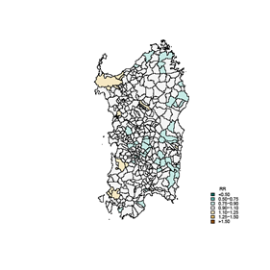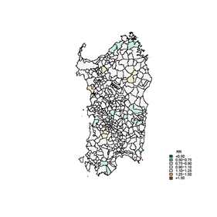
A- 1992-1997 B - 1998-2003
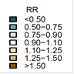
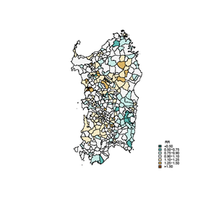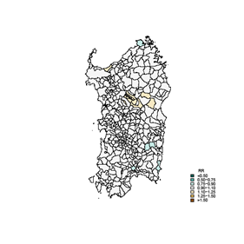
C- 2004-2009 D - 2010-2015
Figure 1: RR MEN 1992-2015

PRPs for men show (not reported here) in all periods an excess risk in northwestern and southwestern municipalities, in the provinces of Sassari, Medio-Campidano and Carbonia-Iglesias. In the last two periods a high-risk pattern in the province of Nuoro emerges, the map showing a more pronounced cluster in the last period. Municipalities in the south, northeast and southeast show low risk of mortality and this pattern varies slightly throughout the study period. Table 1 shows for the first and the last period under analysis, the relationship between mortality and the deprivation index after including it in the estimated spatial model in the first and the last period of the study for men and for women.
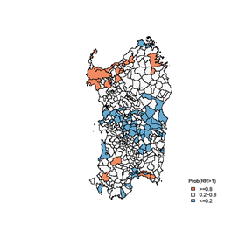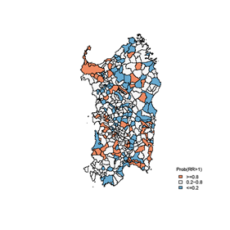
A- 1992-1997 B-1998-2003
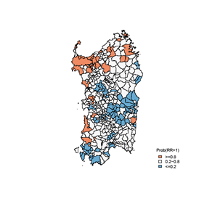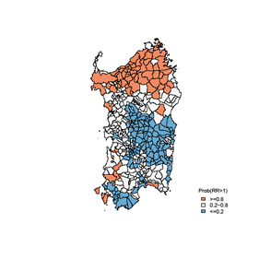
C- 2004-2009 D -.2010-2015
Figure 2: PRP Women

A slight increase in risk between the highest and lowest income categories can be observed in all periods, especially for men, but most credibility intervals are not statistically significant. For women, a threshold effect in the risk of death by level of deprivation emerges in the last two periods of study, while for men we cannot identify a similar temporal trend. For men, the first and second periods stand out, with almost all credibility intervals statistically significant.
Our results do not show a clear association between the deprivation index used and the risk of death, thus suggesting the necessity of studying other possible explanatory variables affecting mortality rates.
Table 1: Deprivation index-adjusted model.
 |  | 1 - MEN |  | 2-WOMEN
Period | DI LEVEL | RR | IC95% | RR | IC95%
1992-1997 | 1 (REF) | 1 | - | 1 | -
 | 2 | 1.11 | 0.98-2.23 | 0.99 | 0.93-1.04
 | 3 | 1.23 | 1.02-3.22 | 0.98 | 0.92-1.03
 | 4 | 1.76 | 1.02-2.87 | 1.01 | 0.95-1.07
 | 5 | 1.23 | 1.05-2.96 | 0.99 | 0.93-1.05
2010-2015 | 1 (REF) | 1 | - | 1 | -
 | 2 | 0.97 | 0.31-1.69 | 0.97 | 0.20-2.09
 | 3 | 1.01 | 0.20-2.04 | 0.95 | 0.20-2.15
 | 4 | 0.73 | 0.01-1.10 | 0.65 | 0.00-3.15
 | 5 | 1.18 | 0.34-2.64 | 1.19 | 0.22-3.97

- Conclusions
The results of spatial analysis confirm those obtained by [3]. The largest increase in mortality rates in the period 1992-2015 was indeed recorded in the industrial areas of Northern Sardinia, and this worsening seems to be not ascribable neither to the age structure of the population nor to the level of deprivation.



References
- Poulain, M., G. M. Pes, C. Grasland, C. Carru, L. Ferrucci, G. Baggio, C. Franceschi, and Deiana, L.: Identification of a Geographic Area Characterized by Extreme Longevity in the Sardinia Island: The AKEA Study. Experimental Gerontology 2004; 39 (9): 1423–1429
- Pes, G. M., Tolu, F., Poulain, M., Errigo, A., Masala, S., Pietrobelli, A., Battistini, N. C., & Maioli, M.: Lifestyle and nutrition related to male longevity in Sardinia: An ecological study”, Nutrition, Metabolism and Cardiovascular Diseases 2013; 23 (3), 212-219.
- Caselli, G., Lipsi, R .M. :Survival differences among the oldest old in Sardinia: who, what, where and why?. Demographic Research 2006, 14 (13), 267-294.
- Biggeri, A., Lagazio, C., Catelan, D., Pirastru, R., Casson, F., Terracini, B.: Ambiente e salute nelle aree a rischio della Sardegna. Epidemologia e Prevenzione, gen-feb 2006, supplemento 1.
http://www.rsc.org/dose/title of subordinate document. Cited 15 Jan 1999
- Besag J, York J, Mollié A. Bayesian image restoration, with two applications in spatial statistics. Ann Inst Stat Math 1991; 43: 1-20.
- Caranci N, Biggeri A, Grisotto L, Pacelli B, Spadea T, Costa G. L’indice di deprivazione italiano a livello di sezione di censimento: definizione, descrizione e associazione con la mortalità. Epidemiol Prev 2010; 34 (4): 167-176
- Brooks SP, Gelman A. Alternative methods for monitoring convergence of iterative simulations. J Comput Graph Stat. 1998; 7:434-455. .
- Richardson S, Thomson A, Best N, Elliott P. Interpreting posterior relative risk estimates in disease-mapping studies. Environ Health Perspect 2004, 112: 1016-1025.

Vanessa Santos Sanchez, Department of Economics and Business; University of Sassari; email: vanesasantossanchez@gmail.com; Corresponding author. Gabriele Ruiu, Department of Economics and Business; University of Sassari; email: gruiu@uniss.it Marco Breschi, Department of Economics and Business; University of Sassari; email: breschi@uniss.it Lucia Pozzi, Department of Economics and Business; University of Sassari; email: lpozzi@uniss.it

