Tourist flows and museum admissions in Italy: an integrated analysis
Flussi turistici e visitatori dei musei in Italia: un analisi integrata
Lorenzo Cavallo, Francesca Petrei, Maria Teresa Santoro
Abstract The main aims of this paper are to analyse cultural tourism in Italy and its relationship with the territory and to provide a tool for policy makers to identify the local dynamics and choose the best development policies. The cultural tourism is studied trough the relation between tourism and cultural statistics.
The analysis uses a spatial approach to identify well-defined geographical areas having significant different - touristic and cultural - characteristics. In order to identify the areas with the greatest cultural-tourism vocation, it is proposed a classification of the municipalities, focusing on some case studies.
Abstract Il principale obiettivo di questo lavoro è analizzare il turismo culturale e la sua relazione con il territorio, in modo da fornire uno strumento ai policy makers per conoscere le dinamiche del proprio territorio e di intervenire con le adeguate politiche di sviluppo. Attraverso l’analisi spaziale sono individuate le aree geografiche con differenti caratteristiche dal punto di vista turistico e culturale ed è proposta una categorizzazione del territorio italiano in base a una più o meno accentuata vocazione turistica o culturale.
Key words: cultural tourism, heritage tourism, tourism flows, museums, visitors
- Introduction
The most visible contribution of culture to local development lies in its ability to attract tourists and the consequent positive effects on spending, incomes and employment (Streeten P., 2006. Leslie D., Sigala M., 2005).
This viewpoint has inspired many studies since the early 1980s that have attempted to demonstrate the impact of culture on local development (OECD, 2005).
Cultural tourism is one of the largest and fastest growing global tourism markets (OECD, 2009), but what exactly is cultural tourism and how can we measure it? One important obstacle to supplying answers to these questions is both the lack of a standard definition and of data on cultural tourism (Noonan D.S., Rizzo I., 2017). The identification of cultural tourism as a growth market has based more on assertion than hard information and more on isolated observations than systematic analysis. It has therefore been difficult to demonstrate just what cultural tourism is, how important is, how fast it is growing, or to identify the reasons why it has grown (Patuelli R., Mussoni M., Candela G., 2013) (Borowiecki K.J, Castiglione C., 2012) (Cuccia T., Cellini R., 2007 - 2013).
Keeping all that in mind, the main aims of this paper are to analyse cultural tourism in Italy and its relationship with the territory and to provide a tool to policy makers to know the territorial dynamics and identify the right development policies.
- Sources and methodology
Giving a quantitative measurement of cultural tourism is even more difficult and, considering the difficulty in defining cultural tourism in a one simple way that covers the whole concept, the most practical approach, therefore, seems to be to choose the definition that is most suited to the task at hand (ATLAS, 2005).
In this paper we decided to start with two assumptions: to use only official statistics as source, in order to consider data with high and uniform standards of quality; to have the territory as fundamental element for the analysis, because culture, tourism and local development are strongly interconnected with the territory.
  - Data
Regarding culture, data on museums and their admissions can be considered, in Italy, as a proxy of the cultural heritage of the territory and are available at a very high territorial detail (at municipality level). Regarding tourism, we chose official statistics on the capacity of accommodation establishments and the occupancy of accommodation establishments, which are available at municipal level.
  - Spatial models and zoning operation
Since the early 1950s tourism has been considered as a purely geographical phenomenon and it is proposed an interpretive scheme of the phenomenon, elaborating a spatial model configuration of tourism (Toschi, 1948). Since the late 1960s, the models of interpretation of the spatial structure of tourism have begun to appear in the geographic field and various models are studied (Pearce, 1989), (Zabbini, 2007).
For this analysis, we used a method that well suits the applications supported by GIS systems, that is to divide the territory into homogeneous areas according to some criteria: the zoning operation.
In our analysis, we proceeded in zoning to identify homogenous areas for cultural and/or touristic characteristics trying to give an immediate and clear picture of the Italian territory. Therefore, through a geographical approach, mapping the variables on tourism (arrivals and bed-places) and culture (museums/cultural exhibits and admissions) at Italian municipality level, the analysis allowed us to identify well-defined geographical areas, having significant different tourism and cultural characteristics.
- The integrated data analysis: classification of the Italian municipalities
For our integrated analysis, we used the final data of the year 2015 on number of establishments, number of arrivals at tourist accommodation establishments (A.E.), number of museums and similar institutions and number of admissions at these institutions. According to the combination of the chosen variables, we classified each municipality in the following categories (table 1):
- Municipality without A.E. and without museums;
- Municipality with no. of museums > 0 but without A.E.;
- Municipality with no. of A.E. > 0 but without museums;
- Municipality with no. of A.E. and no. of museums > 0.
We attributed the municipalities of this last category to two sub-categories:
4.a Municipality with balanced presence of admissions and arrivals;
4.b Municipality with unbalanced presence of admissions and arrivals.
For this sub-classification, we created an indicator for Italian municipalities based on two variables: arrivals in accommodation establishments and admissions in museums and cultural exhibits.
In summary, for balanced municipalities the two considered flows - admissions and arrivals - are proportionate, highlighting a strong connection between tourism and culture; for unbalanced municipalities there is a more or less relevant imbalance towards one type of flow.

Table 1: Distribution of the Italian municipalities by the five categories
Category | N. of Municipalities | % on Total
1 | 1,005 | 12.5
2 | 94 | 1.2
3 | 4,608 | 57.2
4 | 2,339 | 29.1
4.a | 652 | 8.1
4.b | 1,687 | 21.0
Total | 8,046 | 100

The municipalities in category 1 are mainly located in the industrial area of the northwest and in the Apennine area of the south; the municipalities in category 2 in the internal areas of the south (including Sardegna) and in the centre-north (see Figure 1). In Toscana, Umbria and Valle d’Aosta, these two categories are completely absent. Municipalities in category 3 are mainly located in the regions of Northern and Southern Italy and, despite being the larger category, there are very few in central Italy.
The balanced municipalities in category 4.a are mainly concentrated in Toscana and Umbria (see Figure 1); then they are along the Adriatic coast of Marche and Emilia-Romagna and in the internal part of Pianura Padana between Bologna and Piacenza. In addition, there are some balanced municipalities in the two provinces of Bolzano and Trento and in southern Italy, along the coast of Puglia and the south coast of Sicilia. Among the balanced municipalities, there are many “provincial capitals”, including Milan, which is one of the municipalities with the largest number of arrivals in Italy. In addition, there are some municipalities usually known for non-cultural tourism, such as Rimini (beach tourism) or Merano (winter and thermal tourism), that seem to have clearly realized good local policies to profitably valorize their cultural resources.
The unbalanced municipalities in category 4.b are uniformly spread all over the national territory, with concentrations in the Alpine area and in the internal area of Marche, Lazio, Puglia, Sicilia and Sardegna.
This analysis shows that in Italy, accommodation establishments are widespread on the territory and it is clear that when a municipality has at least one museum, in most cases, there is at least one accommodation establishment. Therefore, the presence of a cultural resource, such as a museum is, really attracts tourists and services for them, encouraging the development of economic activities on the territory.
Moreover, the territorial differences are quite clear: 1) the regional administrative boundaries (Regions have legislative power over tourism matters); 2) the historical disparities among North, Centre and South of Italy and among non-urban areas, metropolitan areas and coastal areas.
Among the unbalanced municipalities, we define as “municipalities with cultural prevalence (CP)” those having a greater imbalance towards admissions (n. 1,004 municipalities) and as “municipalities with touristic prevalence (TP)” those having imbalance to arrivals (n. 673 municipalities). The unbalanced municipalities are uniformly spread over the territory and more detailed analysis, realized thanks to the knowledge of the territory, reveals important signals (see Figure 2).

Figure 1: Categories of municipalities - Year 2015 | Figure 2: Unbalanced municipality: classification by prevalence (cultural or touristic) - Year 2015
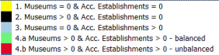  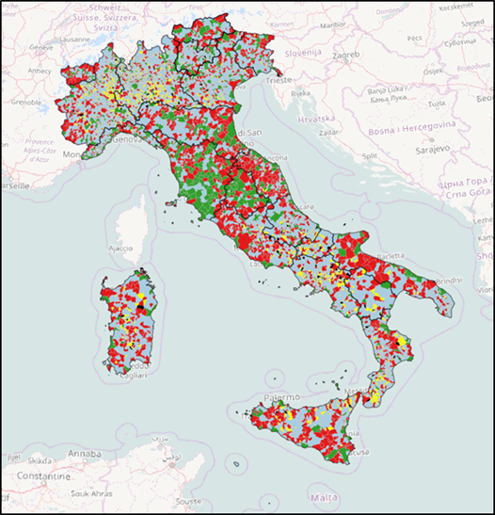 | 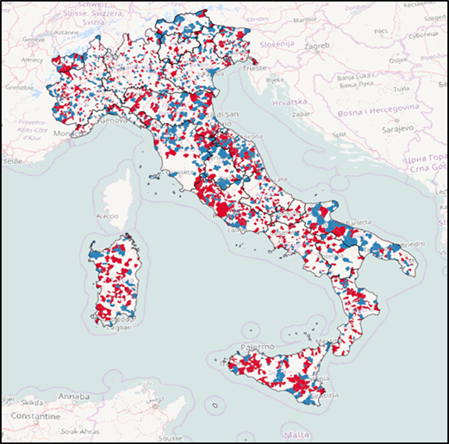
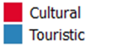
Among the CP municipalities, there are municipalities well known for their specific and attractive cultural resources: Pompei (with its archaeological park), Taormina (with the Greek theater) or Ferrara and Siena, “art cities” with many museums. In these destinations, the phenomenon of “cultural same-day visits” and quick trips are evident. Furthermore, there are also many important provincial capitals, well known as tourist destinations: Roma, Napoli, Pisa, Firenze and Agrigento. These destinations record large numbers of arrivals (they are among the most relevant municipalities from a tourist point of view) but also even a greater presence of same-day visitors for cultural purposes which do not spend nights in accommodation establishments.
Among the TP municipalities, there are all those destinations that have other resources attracting tourists, as well as cultural ones, like as the main destinations for winter activities, thermal, lakeside or beach tourism. In these municipalities there are cultural resources but they are not the main reason for choosing these destinations. In this category, there are also many important municipalities for number of arrivals, as Venice, a destination mainly visited for cultural reasons.

Table 2: Summary of key themes
 | Summary of key themes
1 | museums and accommodation establishments are widely spread over the Italian territory, although they reveal considerable density in some specific areas
2 | arrivals and admissions are highly concentrated in few regions that collect more than half of both flows
3 | part of the structural resources of the country, both touristic and cultural, are underused
4 | the balanced municipalities are a minority, but they could be an example to follow
5 | the unbalanced CP municipalities use well their cultural resources but they have to change to a more structured tourism that leads to greater revenue and local development
6 | the unbalanced TP municipalities have big results in tourism sector but could increase more by the development of their cultural resources
- Final remarks and future outlooks
The main aim of this analysis is to create a tool for policy makers and territorial stakeholders in order to provide them quality statistical information and objective suggestions to make decisions. This is at the initial stage with the intention to develop it using other data to better qualify all the aspects of the territory (e.g. urbanization, coastal/non-coastal, inner areas, parks, etc.). In our opinion, it is essential to start from the territory, in order to define the right local development policies; moreover, a coordinated and efficient governance system is essential in order to plan the actions and follow their developments.
References
- ATLAS: Cultural tourism in Europe. Wallingford, (2005).
- Borowiecki, K. J., Castiglione, C.: Cultural participation and tourism flows: an empirical investigation of Italian provinces. In: Tourism Economics, pp. 241-262, 20(2), (2012).
- Cellini, R., Cuccia, T.: Is cultural Heritage really important for tourists: a contingent rating study. In: Applied Economics, pp. 261-271, n. 39 (2), (2007).
- Cellini, R., Cuccia, T.: Museum and monument attendance and tourism flow: a time series analysis approach. In: Applied Economics, pp. 3473-3482, n. 45, (2013).
- Leslie, D., Sigala, M.: International Cultural Tourism: management, implications and cases. Elsevier Ltd., (2005).
- Noonan, D.S., Rizzo, I.: Economics of cultural tourism: issues and perspectives. In: Journal of Cultural Economics, Issue 2, pp 95–107, Vol. 41, (2017).
- OECD: Culture and Local Development. Paris, (2005).
- OECD: The Impact of Culture on Tourism. Paris, (2009).
- Patuelli, R., Mussoni, M., Candela, G.: The effects of world heritage sites on domestic tourism: A spatial interaction model for Italy. In: Journal of geographical system, pp. 369-402, n. 15, (2013).
- Pearce, D.: Turismo oggi. Ulisse Edizioni, Torino, (1989).
- Streeten, P.: Culture and economic development. In: Ginsburgh, V., Throsby, D. (eds.): Handbook of economics of art and culture, pp. 399- 412, Elsevier, Amsterdam, (2006).
- Toschi, U.: Corso di Geografia economica generale. Macrì, Firenze-Bari, (1948).
- Zabbini, E.: Modelli spaziali dell’evoluzione dei territori turistici. Quaderni - Working Papers DSE 585, marzo, (2007).

Lorenzo Cavallo, Istat; email: cavallo@istat.it; Francesca; Petrei, Istat; email: petrei@istat.it; Maria Teresa Santoro, Istat; masantor@istat.it.
http://www.istat.it/it/archivio/6656
http://www.istat.it/it/archivio/14517
http://www.istat.it/it/archivio/15073
The first step was to consider the arrivals and admissions for 1,000 inhabitants and standardize the variables. Then we generated a synthetic indicator, ranging from 0 to 1, that, when it presented values ​​around 0.5 (between 0.47 and 0.53, with a range of 5%) the municipality is assigned to the category “4.a”, else to the “4.b.” (denoting a municipality with an “imbalance” towards one of the two variables).
The museum offer in these municipalities is an important and “functional” resource for the territory because it actually attracts tourists: these latter not only visit museums but they also spend - nights there. Probably the main motivation of tourists going to these destinations is the culture.

